**What is cloud computing**

Cloud computing is the delivery of computing services over the internet. Computing services include common IT infrastructure such as virtual machines, storage, databases, and networking. Cloud services also expand the traditional IT offerings to include things like Internet of Things (IoT), machine learning (ML), and artificial intelligence (AI).

Because cloud computing uses the internet to deliver these services, it doesn’t have to be constrained by physical infrastructure the same way that a traditional datacenter is. That means if you need to increase your IT infrastructure rapidly, you don’t have to wait to build a new datacenter—you can use the cloud to rapidly expand your IT footprint.

**Describe the shared responsibility model**

You may have heard of the shared responsibility model, but you may not understand what it means or how it impacts cloud computing.

Start with a traditional corporate datacenter. The company is responsible for maintaining the physical space, ensuring security, and maintaining or replacing the servers if anything happens. The IT department is responsible for maintaining all the infrastructure and software needed to keep the datacenter up and running. They’re also likely to be responsible for keeping all systems patched and on the correct version.

With the shared responsibility model, these responsibilities get shared between the cloud provider and the consumer. Physical security, power, cooling, and network connectivity are the responsibility of the cloud provider. The consumer isn’t collocated with the datacenter, so it wouldn’t make sense for the consumer to have any of those responsibilities.

At the same time, the consumer is responsible for the data and information stored in the cloud. (You wouldn’t want the cloud provider to be able to read your information.) The consumer is also responsible for access security, meaning you only give access to those who need it.

Then, for some things, the responsibility depends on the situation. If you’re using a cloud SQL database, the cloud provider would be responsible for maintaining the actual database. However, you’re still responsible for the data that gets ingested into the database. If you deployed a virtual machine and installed an SQL database on it, you’d be responsible for database patches and updates, as well as maintaining the data and information stored in the database.

With an on-premises datacenter, you’re responsible for everything. With cloud computing, those responsibilities shift. The shared responsibility model is heavily tied into the cloud service types (covered later in this learning path): infrastructure as a service (IaaS), platform as a service (PaaS), and software as a service (SaaS). IaaS places the most responsibility on the consumer, with the cloud provider being responsible for the basics of physical security, power, and connectivity. On the other end of the spectrum, SaaS places most of the responsibility with the cloud provider. PaaS, being a middle ground between IaaS and SaaS, rests somewhere in the middle and evenly distributes responsibility between the cloud provider and the consumer.

The following diagram highlights how the Shared Responsibility Model informs who is responsible for what, depending on the cloud service type.

When using a cloud provider, you’ll always be responsible for:

* The information and data stored in the cloud
* Devices that are allowed to connect to your cloud (cell phones, computers, and so on)
* The accounts and identities of the people, services, and devices within your organization

The cloud provider is always responsible for:

* The physical datacenter
* The physical network
* The physical hosts

Your service model will determine responsibility for things like:

* Operating systems
* Network controls
* Applications
* Identity and infrastructure

# Define cloud models

What are cloud models? The cloud models define the deployment type of cloud resources. The three main cloud models are: private, public, and hybrid.

## Private cloud

Let’s start with a private cloud. A private cloud is, in some ways, the natural evolution from a corporate datacenter. It’s a cloud (delivering IT services over the internet) that’s used by a single entity. Private cloud provides much greater control for the company and its IT department. However, it also comes with greater cost and fewer of the benefits of a public cloud deployment. Finally, a private cloud may be hosted from your on site datacenter. It may also be hosted in a dedicated datacenter offsite, potentially even by a third party that has dedicated that datacenter to your company.

## Public cloud

A public cloud is built, controlled, and maintained by a third-party cloud provider. With a public cloud, anyone that wants to purchase cloud services can access and use resources. The general public availability is a key difference between public and private clouds.

## Hybrid cloud

A hybrid cloud is a computing environment that uses both public and private clouds in an inter-connected environment. A hybrid cloud environment can be used to allow a private cloud to surge for increased, temporary demand by deploying public cloud resources. Hybrid cloud can be used to provide an extra layer of security. For example, users can flexibly choose which services to keep in public cloud and which to deploy to their private cloud infrastructure.

The following table highlights a few key comparative aspects between the cloud models.

Expand table

| **Public cloud** | **Private cloud** | **Hybrid cloud** |
| --- | --- | --- |
| No capital expenditures to scale up | Organizations have complete control over resources and security | Provides the most flexibility |
| Applications can be quickly provisioned and deprovisioned | Data is not collocated with other organizations’ data | Organizations determine where to run their applications |
| Organizations pay only for what they use | Hardware must be purchased for startup and maintenance | Organizations control security, compliance, or legal requirements |
| Organizations don’t have complete control over resources and security | Organizations are responsible for hardware maintenance and updates |  |

## Multi-cloud

A fourth, and increasingly likely scenario is a multi-cloud scenario. In a multi-cloud scenario, you use multiple public cloud providers. Maybe you use different features from different cloud providers. Or maybe you started your cloud journey with one provider and are in the process of migrating to a different provider. Regardless, in a multi-cloud environment you deal with two (or more) public cloud providers and manage resources and security in both environments.

## Azure Arc

Azure Arc is a set of technologies that helps manage your cloud environment. Azure Arc can help manage your cloud environment, whether it's a public cloud solely on Azure, a private cloud in your datacenter, a hybrid configuration, or even a multi-cloud environment running on multiple cloud providers at once.

## Azure VMware Solution

What if you’re already established with VMware in a private cloud environment but want to migrate to a public or hybrid cloud? Azure VMware Solution lets you run your VMware workloads in Azure with seamless integration and scalability.

# Describe the consumption-based model

When comparing IT infrastructure models, there are two types of expenses to consider. Capital expenditure (CapEx) and operational expenditure (OpEx).

CapEx is typically a one-time, up-front expenditure to purchase or secure tangible resources. A new building, repaving the parking lot, building a datacenter, or buying a company vehicle are examples of CapEx.

In contrast, OpEx is spending money on services or products over time. Renting a convention center, leasing a company vehicle, or signing up for cloud services are all examples of OpEx.

Cloud computing falls under OpEx because cloud computing operates on a consumption-based model. With cloud computing, you don’t pay for the physical infrastructure, the electricity, the security, or anything else associated with maintaining a datacenter. Instead, you pay for the IT resources you use. If you don’t use any IT resources this month, you don’t pay for any IT resources.

This consumption-based model has many benefits, including:

* No upfront costs.
* No need to purchase and manage costly infrastructure that users might not use to its fullest potential.
* The ability to pay for more resources when they're needed.
* The ability to stop paying for resources that are no longer needed.

With a traditional datacenter, you try to estimate the future resource needs. If you overestimate, you spend more on your datacenter than you need to and potentially waste money. If you underestimate, your datacenter will quickly reach capacity and your applications and services may suffer from decreased performance. Fixing an under-provisioned datacenter can take a long time. You may need to order, receive, and install more hardware. You'll also need to add power, cooling, and networking for the extra hardware.

In a cloud-based model, you don’t have to worry about getting the resource needs just right. If you find that you need more virtual machines, you add more. If the demand drops and you don’t need as many virtual machines, you remove machines as needed. Either way, you’re only paying for the virtual machines that you use, not the “extra capacity” that the cloud provider has on hand.

## Compare cloud pricing models

Cloud computing is the delivery of computing services over the internet by using a pay-as-you-go pricing model. You typically pay only for the cloud services you use, which helps you:

* Plan and manage your operating costs.
* Run your infrastructure more efficiently.
* Scale as your business needs change.

To put it another way, cloud computing is a way to rent compute power and storage from someone else’s datacenter. You can treat cloud resources like you would resources in your own datacenter. However, unlike in your own datacenter, when you're done using cloud resources, you give them back. You’re billed only for what you use.

Instead of maintaining CPUs and storage in your datacenter, you rent them for the time that you need them. The cloud provider takes care of maintaining the underlying infrastructure for you. The cloud enables you to quickly solve your toughest business challenges and bring cutting-edge solutions to your users.

# Describe the benefits of high availability and scalability in the cloud

When building or deploying a cloud application, two of the biggest considerations are uptime (or availability) and the ability to handle demand (or scale).

## High availability

When you’re deploying an application, a service, or any IT resources, it’s important the resources are available when needed. High availability focuses on ensuring maximum availability, regardless of disruptions or events that may occur.

When you’re architecting your solution, you’ll need to account for service availability guarantees. Azure is a highly available cloud environment with uptime guarantees depending on the service. These guarantees are part of the service-level agreements (SLAs).

This short video describes Azure SLAs in more detail.

## Scalability

Another major benefit of cloud computing is the scalability of cloud resources. Scalability refers to the ability to adjust resources to meet demand. If you suddenly experience peak traffic and your systems are overwhelmed, the ability to scale means you can add more resources to better handle the increased demand.

The other benefit of scalability is that you aren't overpaying for services. Because the cloud is a consumption-based model, you only pay for what you use. If demand drops off, you can reduce your resources and thereby reduce your costs.

Scaling generally comes in two varieties: vertical and horizontal. Vertical scaling is focused on increasing or decreasing the capabilities of resources. Horizontal scaling is adding or subtracting the number of resources.

### Vertical scaling

With vertical scaling, if you were developing an app and you needed more processing power, you could vertically scale up to add more CPUs or RAM to the virtual machine. Conversely, if you realized you had over-specified the needs, you could vertically scale down by lowering the CPU or RAM specifications.

### Horizontal scaling

With horizontal scaling, if you suddenly experienced a steep jump in demand, your deployed resources could be scaled out (either automatically or manually). For example, you could add additional virtual machines or containers, scaling out. In the same manner, if there was a significant drop in demand, deployed resources could be scaled in (either automatically or manually), scaling in.

# Describe the benefits of reliability and predictability in the cloud

Reliability and predictability are two crucial cloud benefits that help you develop solutions with confidence.

## Reliability

Reliability is the ability of a system to recover from failures and continue to function. It's also one of the pillars of the Microsoft Azure Well-Architected Framework.

The cloud, by virtue of its decentralized design, naturally supports a reliable and resilient infrastructure. With a decentralized design, the cloud enables you to have resources deployed in regions around the world. With this global scale, even if one region has a catastrophic event other regions are still up and running. You can design your applications to automatically take advantage of this increased reliability. In some cases, your cloud environment itself will automatically shift to a different region for you, with no action needed on your part. You’ll learn more about how Azure leverages global scale to provide reliability later in this series.

## Predictability

Predictability in the cloud lets you move forward with confidence. Predictability can be focused on performance predictability or cost predictability. Both performance and cost predictability are heavily influenced by the Microsoft Azure Well-Architected Framework. Deploy a solution built around this framework and you have a solution whose cost and performance are predictable.

### Performance

Performance predictability focuses on predicting the resources needed to deliver a positive experience for your customers. Autoscaling, load balancing, and high availability are just some of the cloud concepts that support performance predictability. If you suddenly need more resources, autoscaling can deploy additional resources to meet the demand, and then scale back when the demand drops. Or if the traffic is heavily focused on one area, load balancing will help redirect some of the overload to less stressed areas.

### Cost

Cost predictability is focused on predicting or forecasting the cost of the cloud spend. With the cloud, you can track your resource use in real time, monitor resources to ensure that you’re using them in the most efficient way, and apply data analytics to find patterns and trends that help better plan resource deployments. By operating in the cloud and using cloud analytics and information, you can predict future costs and adjust your resources as needed. You can even use tools like the Total Cost of Ownership (TCO) or Pricing Calculator to get an estimate of potential cloud spend.

**Describe the benefits of security and governance in the cloud**

Whether you’re deploying infrastructure as a service or software as a service, cloud features support governance and compliance. Things like set templates help ensure that all your deployed resources meet corporate standards and government regulatory requirements. Plus, you can update all your deployed resources to new standards as standards change. Cloud-based auditing helps flag any resource that’s out of compliance with your corporate standards and provides mitigation strategies. Depending on your operating model, software patches and updates may also automatically be applied, which helps with both governance and security.

On the security side, you can find a cloud solution that matches your security needs. If you want maximum control of security, infrastructure as a service provides you with physical resources but lets you manage the operating systems and installed software, including patches and maintenance. If you want patches and maintenance taken care of automatically, platform as a service or software as a service deployments may be the best cloud strategies for you.

And because the cloud is intended as an over-the-internet delivery of IT resources, cloud providers are typically well suited to handle things like distributed denial of service (DDoS) attacks, making your network more robust and secure.

By establishing a good governance footprint early, you can keep your cloud footprint updated, secure, and well managed.

# Describe the benefits of manageability in the cloud

A major benefit of cloud computing is the manageability options. There are two types of manageability for cloud computing that you’ll learn about in this series, and both are excellent benefits.

## Management of the cloud

Management of the cloud speaks to managing your cloud resources. In the cloud, you can:

* Automatically scale resource deployment based on need.
* Deploy resources based on a preconfigured template, removing the need for manual configuration.
* Monitor the health of resources and automatically replace failing resources.
* Receive automatic alerts based on configured metrics, so you’re aware of performance in real time.

## Management in the cloud

Management in the cloud speaks to how you’re able to manage your cloud environment and resources. You can manage these:

* Through a web portal.
* Using a command line interface.
* Using APIs.
* Using PowerShell.

# Describe Infrastructure as a Service

Infrastructure as a service (IaaS) is the most flexible category of cloud services, as it provides you the maximum amount of control for your cloud resources. In an IaaS model, the cloud provider is responsible for maintaining the hardware, network connectivity (to the internet), and physical security. You’re responsible for everything else: operating system installation, configuration, and maintenance; network configuration; database and storage configuration; and so on. With IaaS, you’re essentially renting the hardware in a cloud datacenter, but what you do with that hardware is up to you.

## Shared responsibility model

The shared responsibility model applies to all the cloud service types. IaaS places the largest share of responsibility with you. The cloud provider is responsible for maintaining the physical infrastructure and its access to the internet. You’re responsible for installation and configuration, patching and updates, and security.

## Scenarios

Some common scenarios where IaaS might make sense include:

* Lift-and-shift migration: You’re setting up cloud resources similar to your on-prem datacenter, and then simply moving the things running on-prem to running on the IaaS infrastructure.
* Testing and development: You have established configurations for development and test environments that you need to rapidly replicate. You can start up or shut down the different environments rapidly with an IaaS structure, while maintaining complete control.

# Describe Platform as a Service

Platform as a service (PaaS) is a middle ground between renting space in a datacenter (infrastructure as a service) and paying for a complete and deployed solution (software as a service). In a PaaS environment, the cloud provider maintains the physical infrastructure, physical security, and connection to the internet. They also maintain the operating systems, middleware, development tools, and business intelligence services that make up a cloud solution. In a PaaS scenario, you don't have to worry about the licensing or patching for operating systems and databases.

PaaS is well suited to provide a complete development environment without the headache of maintaining all the development infrastructure.

## Shared responsibility model

The shared responsibility model applies to all the cloud service types. PaaS splits the responsibility between you and the cloud provider. The cloud provider is responsible for maintaining the physical infrastructure and its access to the internet, just like in IaaS. In the PaaS model, the cloud provider will also maintain the operating systems, databases, and development tools. Think of PaaS like using a domain joined machine: IT maintains the device with regular updates, patches, and refreshes.

Depending on the configuration, you or the cloud provider may be responsible for networking settings and connectivity within your cloud environment, network and application security, and the directory infrastructure.

## Scenarios

Some common scenarios where PaaS might make sense include:

* Development framework: PaaS provides a framework that developers can build upon to develop or customize cloud-based applications. Similar to the way you create an Excel macro, PaaS lets developers create applications using built-in software components. Cloud features such as scalability, high-availability, and multi-tenant capability are included, reducing the amount of coding that developers must do.
* Analytics or business intelligence: Tools provided as a service with PaaS allow organizations to analyze and mine their data, finding insights and patterns and predicting outcomes to improve forecasting, product design decisions, investment returns, and other business decisions.

# Describe Software as a Service

Software as a service (SaaS) is the most complete cloud service model from a product perspective. With SaaS, you’re essentially renting or using a fully developed application. Email, financial software, messaging applications, and connectivity software are all common examples of a SaaS implementation.

While the SaaS model may be the least flexible, it’s also the easiest to get up and running. It requires the least amount of technical knowledge or expertise to fully employ.

## Shared responsibility model

The shared responsibility model applies to all the cloud service types. SaaS is the model that places the most responsibility with the cloud provider and the least responsibility with the user. In a SaaS environment you’re responsible for the data that you put into the system, the devices that you allow to connect to the system, and the users that have access. Nearly everything else falls to the cloud provider. The cloud provider is responsible for physical security of the datacenters, power, network connectivity, and application development and patching.

## Scenarios

Some common scenarios for SaaS are:

* Email and messaging.
* Business productivity applications.
* Finance and expense tracking.

Azure is a continually expanding set of cloud services that help you meet current and future business challenges. Azure gives you the freedom to build, manage, and deploy applications on a massive global network using your favorite tools and frameworks.

## What does Azure offer?

**Limitless innovation.** Build intelligent apps and solutions with advanced technology, tools, and services to take your business to the next level. Seamlessly unify your technology to simplify platform management and to deliver innovations efficiently and securely on a trusted cloud.

* **Bring ideas to life:** Build on a trusted platform to advance your organization with industry-leading AI and cloud services.
* **Seamlessly unify:** Efficiently manage all your infrastructure, data, analytics, and AI solutions across an integrated platform.
* **Innovate on trust:** Rely on trusted technology from a partner who's dedicated to security and responsibility.

## What can I do with Azure?

Azure provides more than 100 services that enable you to do everything from running your existing applications on virtual machines to exploring new software paradigms, such as intelligent bots and mixed reality.

Many teams start exploring the cloud by moving their existing applications to virtual machines (VMs) that run in Azure. Migrating your existing apps to VMs is a good start, but the cloud is much more than a different place to run your VMs.

For example, Azure provides artificial intelligence (AI) and machine-learning (ML) services that can naturally communicate with your users through vision, hearing, and speech. It also provides storage solutions that dynamically grow to accommodate massive amounts of data. Azure services enable solutions that aren't feasible without the power of the cloud.

# Get started with Azure accounts

To create and use Azure services, you need an Azure subscription. When you're completing Learn modules, most of the time a temporary subscription is created for you, which runs in an environment called the Learn sandbox. When you're working with your own applications and business needs, you need to create an Azure account, and a subscription will be created for you. After you've created an Azure account, you're free to create additional subscriptions. For example, your company might use a single Azure account for your business and separate subscriptions for development, marketing, and sales departments. After you've created an Azure subscription, you can start creating Azure resources within each subscription.

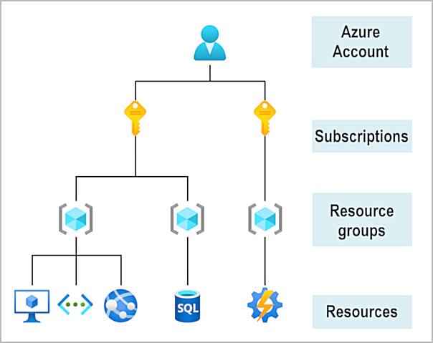

If you're new to Azure, you can sign up for a free account on the Azure website to start exploring at no cost to you. When you're ready, you can choose to upgrade your free account. You can also create a new subscription that enables you to start paying for Azure services you need beyond the limits of a free account.

# Describe Azure physical infrastructure

Throughout your journey with Microsoft Azure, you’ll hear and use terms like Regions, Availability Zones, Resources, Subscriptions, and more. This module focuses on the core architectural components of Azure. The core architectural components of Azure may be broken down into two main groupings: the physical infrastructure, and the management infrastructure.

## Physical infrastructure

The physical infrastructure for Azure starts with datacenters. Conceptually, the datacenters are the same as large corporate datacenters. They’re facilities with resources arranged in racks, with dedicated power, cooling, and networking infrastructure.

As a global cloud provider, Azure has datacenters around the world. However, these individual datacenters aren’t directly accessible. Datacenters are grouped into Azure Regions or Azure Availability Zones that are designed to help you achieve resiliency and reliability for your business-critical workloads.

The [Global infrastructure](https://infrastructuremap.microsoft.com/) site gives you a chance to interactively explore the underlying Azure infrastructure.

### Regions

A region is a geographical area on the planet that contains at least one, but potentially multiple datacenters that are nearby and networked together with a low-latency network. Azure intelligently assigns and controls the resources within each region to ensure workloads are appropriately balanced.

When you deploy a resource in Azure, you'll often need to choose the region where you want your resource deployed.

**Note**

Some services or virtual machine (VM) features are only available in certain regions, such as specific VM sizes or storage types. There are also some global Azure services that don't require you to select a particular region, such as Microsoft Entra ID, Azure Traffic Manager, and Azure DNS.

### Availability Zones

Availability zones are physically separate datacenters within an Azure region. Each availability zone is made up of one or more datacenters equipped with independent power, cooling, and networking. An availability zone is set up to be an isolation boundary. If one zone goes down, the other continues working. Availability zones are connected through high-speed, private fiber-optic networks.

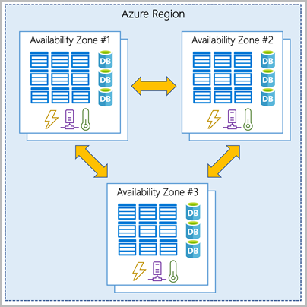

**Important**

To ensure resiliency, a minimum of three separate availability zones are present in all availability zone-enabled regions. However, not all Azure Regions currently support availability zones.

#### Use availability zones in your apps

You want to ensure your services and data are redundant so you can protect your information in case of failure. When you host your infrastructure, setting up your own redundancy requires that you create duplicate hardware environments. Azure can help make your app highly available through availability zones.

You can use availability zones to run mission-critical applications and build high-availability into your application architecture by co-locating your compute, storage, networking, and data resources within an availability zone and replicating in other availability zones. Keep in mind that there could be a cost to duplicating your services and transferring data between availability zones.

Availability zones are primarily for VMs, managed disks, load balancers, and SQL databases. Azure services that support availability zones fall into three categories:

* Zonal services: You pin the resource to a specific zone (for example, VMs, managed disks, IP addresses).
* Zone-redundant services: The platform replicates automatically across zones (for example, zone-redundant storage, SQL Database).
* Non-regional services: Services are always available from Azure geographies and are resilient to zone-wide outages as well as region-wide outages.

Even with the additional resiliency that availability zones provide, it’s possible that an event could be so large that it impacts multiple availability zones in a single region. To provide even further resilience, Azure has Region Pairs.

### Region pairs

Most Azure regions are paired with another region within the same geography (such as US, Europe, or Asia) at least 300 miles away. This approach allows for the replication of resources across a geography that helps reduce the likelihood of interruptions because of events such as natural disasters, civil unrest, power outages, or physical network outages that affect an entire region. For example, if a region in a pair was affected by a natural disaster, services would automatically fail over to the other region in its region pair.

**Important**

Not all Azure services automatically replicate data or automatically fall back from a failed region to cross-replicate to another enabled region. In these scenarios, recovery and replication must be configured by the customer.

Examples of region pairs in Azure are West US paired with East US and South-East Asia paired with East Asia. Because the pair of regions are directly connected and far enough apart to be isolated from regional disasters, you can use them to provide reliable services and data redundancy.

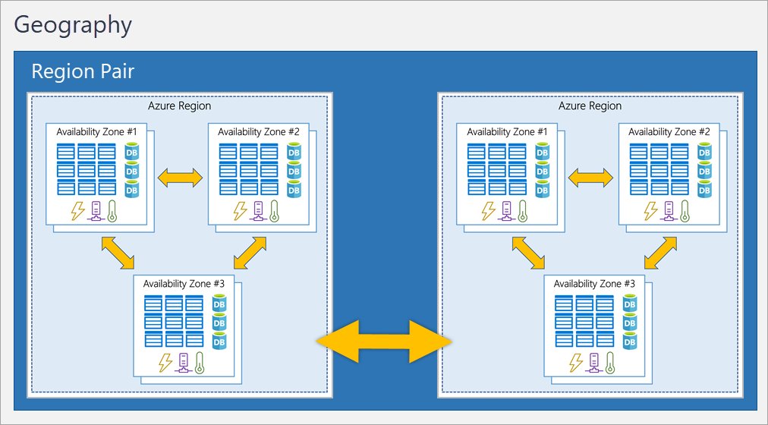

#### Additional advantages of region pairs:

* If an extensive Azure outage occurs, one region out of every pair is prioritized to make sure at least one is restored as quickly as possible for applications hosted in that region pair.
* Planned Azure updates are rolled out to paired regions one region at a time to minimize downtime and risk of application outage.
* Data continues to reside within the same geography as its pair (except for Brazil South) for tax- and law-enforcement jurisdiction purposes.

**Important**

Most regions are paired in two directions, meaning they are the backup for the region that provides a backup for them (West US and East US back each other up). However, some regions, such as West India and Brazil South, are paired in only one direction. In a one-direction pairing, the Primary region does not provide backup for its secondary region. So, even though West India’s secondary region is South India, South India does not rely on West India. West India's secondary region is South India, but South India's secondary region is Central India. Brazil South is unique because it's paired with a region outside of its geography. Brazil South's secondary region is South Central US. The secondary region of South Central US isn't Brazil South.

### Sovereign Regions

In addition to regular regions, Azure also has sovereign regions. Sovereign regions are instances of Azure that are isolated from the main instance of Azure. You may need to use a sovereign region for compliance or legal purposes.

Azure sovereign regions include:

* US DoD Central, US Gov Virginia, US Gov Iowa and more: These regions are physical and logical network-isolated instances of Azure for U.S. government agencies and partners. These datacenters are operated by screened U.S. personnel and include additional compliance certifications.
* China East, China North, and more: These regions are available through a unique partnership between Microsoft and 21Vianet, whereby Microsoft doesn't directly maintain the datacenters.

# Describe Azure management infrastructure

The management infrastructure includes Azure resources and resource groups, subscriptions, and accounts. Understanding the hierarchical organization will help you plan your projects and products within Azure.

## Azure resources and resource groups

A resource is the basic building block of Azure. Anything you create, provision, deploy, etc. is a resource. Virtual Machines (VMs), virtual networks, databases, cognitive services, etc. are all considered resources within Azure.

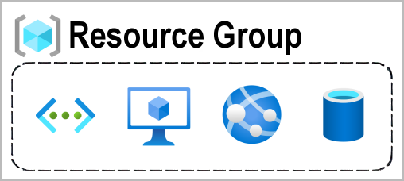

Resource groups are simply groupings of resources. When you create a resource, you’re required to place it into a resource group. While a resource group can contain many resources, a single resource can only be in one resource group at a time. Some resources may be moved between resource groups, but when you move a resource to a new group, it will no longer be associated with the former group. Additionally, resource groups can't be nested, meaning you can’t put resource group B inside of resource group A.

Resource groups provide a convenient way to group resources together. When you apply an action to a resource group, that action will apply to all the resources within the resource group. If you delete a resource group, all the resources will be deleted. If you grant or deny access to a resource group, you’ve granted or denied access to all the resources within the resource group.

When you’re provisioning resources, it’s good to think about the resource group structure that best suits your needs.

For example, if you’re setting up a temporary dev environment, grouping all the resources together means you can deprovision all of the associated resources at once by deleting the resource group. If you’re provisioning compute resources that will need three different access schemas, it may be best to group resources based on the access schema, and then assign access at the resource group level.

There aren’t hard rules about how you use resource groups, so consider how to set up your resource groups to maximize their usefulness for you.

## Azure subscriptions

In Azure, subscriptions are a unit of management, billing, and scale. Similar to how resource groups are a way to logically organize resources, subscriptions allow you to logically organize your resource groups and facilitate billing.

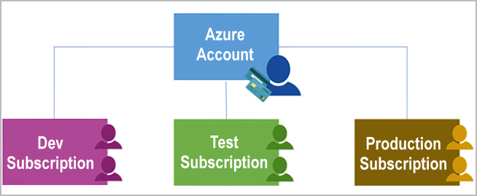

Using Azure requires an Azure subscription. A subscription provides you with authenticated and authorized access to Azure products and services. It also allows you to provision resources. An Azure subscription links to an Azure account, which is an identity in Microsoft Entra ID or in a directory that Microsoft Entra ID trusts.

An account can have multiple subscriptions, but it’s only required to have one. In a multi-subscription account, you can use the subscriptions to configure different billing models and apply different access-management policies. You can use Azure subscriptions to define boundaries around Azure products, services, and resources. There are two types of subscription boundaries that you can use:

* **Billing boundary**: This subscription type determines how an Azure account is billed for using Azure. You can create multiple subscriptions for different types of billing requirements. Azure generates separate billing reports and invoices for each subscription so that you can organize and manage costs.
* **Access control boundary**: Azure applies access-management policies at the subscription level, and you can create separate subscriptions to reflect different organizational structures. An example is that within a business, you have different departments to which you apply distinct Azure subscription policies. This billing model allows you to manage and control access to the resources that users provision with specific subscriptions.

### Create additional Azure subscriptions

Similar to using resource groups to separate resources by function or access, you might want to create additional subscriptions for resource or billing management purposes. For example, you might choose to create additional subscriptions to separate:

* **Environments**: You can choose to create subscriptions to set up separate environments for development and testing, security, or to isolate data for compliance reasons. This design is particularly useful because resource access control occurs at the subscription level.
* **Organizational structures**: You can create subscriptions to reflect different organizational structures. For example, you could limit one team to lower-cost resources, while allowing the IT department a full range. This design allows you to manage and control access to the resources that users provision within each subscription.
* **Billing**: You can create additional subscriptions for billing purposes. Because costs are first aggregated at the subscription level, you might want to create subscriptions to manage and track costs based on your needs. For instance, you might want to create one subscription for your production workloads and another subscription for your development and testing workloads.

## Azure management groups

The final piece is the management group. Resources are gathered into resource groups, and resource groups are gathered into subscriptions. If you’re just starting in Azure that might seem like enough hierarchy to keep things organized. But imagine if you’re dealing with multiple applications, multiple development teams, in multiple geographies.

If you have many subscriptions, you might need a way to efficiently manage access, policies, and compliance for those subscriptions. Azure management groups provide a level of scope above subscriptions. You organize subscriptions into containers called management groups and apply governance conditions to the management groups. All subscriptions within a management group automatically inherit the conditions applied to the management group, the same way that resource groups inherit settings from subscriptions and resources inherit from resource groups. Management groups give you enterprise-grade management at a large scale, no matter what type of subscriptions you might have. Management groups can be nested.

## Management group, subscriptions, and resource group hierarchy

You can build a flexible structure of management groups and subscriptions to organize your resources into a hierarchy for unified policy and access management. The following diagram shows an example of creating a hierarchy for governance by using management groups.

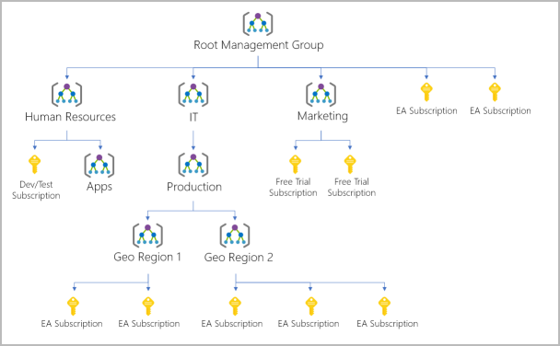

Some examples of how you could use management groups might be:

* **Create a hierarchy that applies a policy**. You could limit VM locations to the US West Region in a group called Production. This policy will inherit onto all the subscriptions that are descendants of that management group and will apply to all VMs under those subscriptions. This security policy can't be altered by the resource or subscription owner, which allows for improved governance.
* **Provide user access to multiple subscriptions**. By moving multiple subscriptions under a management group, you can create one Azure role-based access control (Azure RBAC) assignment on the management group. Assigning Azure RBAC at the management group level means that all sub-management groups, subscriptions, resource groups, and resources underneath that management group would also inherit those permissions. One assignment on the management group can enable users to have access to everything they need instead of scripting Azure RBAC over different subscriptions.

Important facts about management groups:

* 10,000 management groups can be supported in a single directory.
* A management group tree can support up to six levels of depth. This limit doesn't include the root level or the subscription level.
* Each management group and subscription can support only one parent.

# Describe Azure virtual machines

With Azure Virtual Machines (VMs), you can create and use VMs in the cloud. VMs provide infrastructure as a service (IaaS) in the form of a virtualized server and can be used in many ways. Just like a physical computer, you can customize all of the software running on your VM. VMs are an ideal choice when you need:

* Total control over the operating system (OS).
* The ability to run custom software.
* To use custom hosting configurations.

An Azure VM gives you the flexibility of virtualization without having to buy and maintain the physical hardware that runs the VM. However, as an IaaS offering, you still need to configure, update, and maintain the software that runs on the VM.

You can even create or use an already created image to rapidly provision VMs. You can create and provision a VM in minutes when you select a preconfigured VM image. An image is a template used to create a VM and may already include an OS and other software, like development tools or web hosting environments.

## Scale VMs in Azure

You can run single VMs for testing, development, or minor tasks. Or you can group VMs together to provide high availability, scalability, and redundancy. Azure can also manage the grouping of VMs for you with features such as scale sets and availability sets.

### Virtual machine scale sets

Virtual machine scale sets let you create and manage a group of identical, load-balanced VMs. If you simply created multiple VMs with the same purpose, you’d need to ensure they were all configured identically and then set up network routing parameters to ensure efficiency. You’d also have to monitor the utilization to determine if you need to increase or decrease the number of VMs.

Instead, with virtual machine scale sets, Azure automates most of that work. Scale sets allow you to centrally manage, configure, and update a large number of VMs in minutes. The number of VM instances can automatically increase or decrease in response to demand, or you can set it to scale based on a defined schedule. Virtual machine scale sets also automatically deploy a load balancer to make sure that your resources are being used efficiently. With virtual machine scale sets, you can build large-scale services for areas such as compute, big data, and container workloads.

### Virtual machine availability sets

Virtual machine availability sets are another tool to help you build a more resilient, highly available environment. Availability sets are designed to ensure that VMs stagger updates and have varied power and network connectivity, preventing you from losing all your VMs with a single network or power failure.

Availability sets do this by grouping VMs in two ways: update domain and fault domain.

* **Update domain**: The update domain groups VMs that can be rebooted at the same time. This allows you to apply updates while knowing that only one update domain grouping will be offline at a time. All of the machines in one update domain will be updated. An update group going through the update process is given a 30-minute time to recover before maintenance on the next update domain starts.
* **Fault domain**: The fault domain groups your VMs by common power source and network switch. By default, an availability set will split your VMs across up to three fault domains. This helps protect against a physical power or networking failure by having VMs in different fault domains (thus being connected to different power and networking resources).

Best of all, there’s no additional cost for configuring an availability set. You only pay for the VM instances you create.

## Examples of when to use VMs

Some common examples or use cases for virtual machines include:

* **During testing and development**. VMs provide a quick and easy way to create different OS and application configurations. Test and development personnel can then easily delete the VMs when they no longer need them.
* **When running applications in the cloud**. The ability to run certain applications in the public cloud as opposed to creating a traditional infrastructure to run them can provide substantial economic benefits. For example, an application might need to handle fluctuations in demand. Shutting down VMs when you don't need them or quickly starting them up to meet a sudden increase in demand means you pay only for the resources you use.
* **When extending your datacenter to the cloud**: An organization can extend the capabilities of its own on-premises network by creating a virtual network in Azure and adding VMs to that virtual network. Applications like SharePoint can then run on an Azure VM instead of running locally. This arrangement makes it easier or less expensive to deploy than in an on-premises environment.
* **During disaster recovery**: As with running certain types of applications in the cloud and extending an on-premises network to the cloud, you can get significant cost savings by using an IaaS-based approach to disaster recovery. If a primary datacenter fails, you can create VMs running on Azure to run your critical applications and then shut them down when the primary datacenter becomes operational again.

## Move to the cloud with VMs

VMs are also an excellent choice when you move from a physical server to the cloud (also known as lift and shift). You can create an image of the physical server and host it within a VM with little or no changes. Just like a physical on-premises server, you must maintain the VM: you’re responsible for maintaining the installed OS and software.

## VM Resources

When you provision a VM, you’ll also have the chance to pick the resources that are associated with that VM, including:

* Size (purpose, number of processor cores, and amount of RAM)
* Storage disks (hard disk drives, solid state drives, etc.)
* Networking (virtual network, public IP address, and port configuration)

# Describe Azure virtual desktop

Another type of virtual machine is the Azure Virtual Desktop. Azure Virtual Desktop is a desktop and application virtualization service that runs on the cloud. It enables you to use a cloud-hosted version of Windows from any location. Azure Virtual Desktop works across devices and operating systems, and works with apps that you can use to access remote desktops or most modern browsers.

## Enhance security

Azure Virtual Desktop provides centralized security management for users' desktops with Microsoft Entra ID. You can enable multifactor authentication to secure user sign-ins. You can also secure access to data by assigning granular role-based access controls (RBACs) to users.

With Azure Virtual Desktop, the data and apps are separated from the local hardware. The actual desktop and apps are running in the cloud, meaning the risk of confidential data being left on a personal device is reduced. Additionally, user sessions are isolated in both single and multi-session environments.

## Multi-session Windows 10 or Windows 11 deployment

Azure Virtual Desktop lets you use Windows 10 or Windows 11 Enterprise multi-session, the only Windows client-based operating system that enables multiple concurrent users on a single VM. Azure Virtual Desktop also provides a more consistent experience with broader application support compared to Windows Server-based operating systems.

# Describe Azure containers

While virtual machines are an excellent way to reduce costs versus the investments that are necessary for physical hardware, they're still limited to a single operating system per virtual machine. If you want to run multiple instances of an application on a single host machine, containers are an excellent choice.

## What are containers?

Containers are a virtualization environment. Much like running multiple virtual machines on a single physical host, you can run multiple containers on a single physical or virtual host. Unlike virtual machines, you don't manage the operating system for a container. Virtual machines appear to be an instance of an operating system that you can connect to and manage. Containers are lightweight and designed to be created, scaled out, and stopped dynamically. It's possible to create and deploy virtual machines as application demand increases, but containers are a lighter weight, more agile method. Containers are designed to allow you to respond to changes on demand. With containers, you can quickly restart if there's a crash or hardware interruption. One of the most popular container engines is Docker, and Azure supports Docker.

## Compare virtual machines to containers

The following video highlights several of the important differences between virtual machines and containers:

### Azure Container Instances

Azure Container Instances offer the fastest and simplest way to run a container in Azure; without having to manage any virtual machines or adopt any additional services. Azure Container Instances are a platform as a service (PaaS) offering. Azure Container Instances allow you to upload your containers and then the service will run the containers for you.

### Azure Container Apps

Azure Container Apps are similar in many ways to a container instance. They allow you to get up and running right away, they remove the container management piece, and they're a PaaS offering. Container Apps have extra benefits such as the ability to incorporate load balancing and scaling. These other functions allow you to be more elastic in your design.

### Azure Kubernetes Service

Azure Kubernetes Service (AKS) is a container orchestration service. An orchestration service manages the lifecycle of containers. When you're deploying a fleet of containers, AKS can make fleet management simpler and more efficient.

### Use containers in your solutions

Containers are often used to create solutions by using a microservice architecture. This architecture is where you break solutions into smaller, independent pieces. For example, you might split a website into a container hosting your front end, another hosting your back end, and a third for storage. This split allows you to separate portions of your app into logical sections that can be maintained, scaled, or updated independently.

Imagine your website back-end has reached capacity but the front end and storage aren't being stressed. With containers, you could scale the back end separately to improve performance. If something necessitated such a change, you could also choose to change the storage service or modify the front end without impacting any of the other components.

# Describe Azure functions

Azure Functions is an event-driven, serverless compute option that doesn’t require maintaining virtual machines or containers. If you build an app using VMs or containers, those resources have to be “running” in order for your app to function. With Azure Functions, an event wakes the function, alleviating the need to keep resources provisioned when there are no events.

## Serverless computing in Azure

## Benefits of Azure Functions

Using Azure Functions is ideal when you're only concerned about the code running your service and not about the underlying platform or infrastructure. Functions are commonly used when you need to perform work in response to an event (often via a REST request), timer, or message from another Azure service, and when that work can be completed quickly, within seconds or less.

Functions scale automatically based on demand, so they may be a good choice when demand is variable.

Azure Functions runs your code when it's triggered and automatically deallocates resources when the function is finished. In this model, you're only charged for the CPU time used while your function runs.

Functions can be either stateless or stateful. When they're stateless (the default), they behave as if they're restarted every time they respond to an event. When they're stateful (called Durable Functions), a context is passed through the function to track prior activity.

Functions are a key component of serverless computing. They're also a general compute platform for running any type of code. If the needs of the developer's app change, you can deploy the project in an environment that isn't serverless. This flexibility allows you to manage scaling, run on virtual networks, and even completely isolate the functions.

# Describe application hosting options

If you need to host your application on Azure, you might initially turn to a virtual machine (VM) or containers. Both VMs and containers provide excellent hosting solutions. VMs give you maximum control of the hosting environment and allow you to configure it exactly how you want. VMs also may be the most familiar hosting method if you’re new to the cloud. Containers, with the ability to isolate and individually manage different aspects of the hosting solution, can also be a robust and compelling option.

There are other hosting options that you can use with Azure, including Azure App Service.

## Azure App Service

App Service enables you to build and host web apps, background jobs, mobile back-ends, and RESTful APIs in the programming language of your choice without managing infrastructure. It offers automatic scaling and high availability. App Service supports Windows and Linux. It enables automated deployments from GitHub, Azure DevOps, or any Git repo to support a continuous deployment model.

Azure App Service is a robust hosting option that you can use to host your apps in Azure. Azure App Service lets you focus on building and maintaining your app, and Azure focuses on keeping the environment up and running.

Azure App Service is an HTTP-based service for hosting web applications, REST APIs, and mobile back ends. It supports multiple languages, including .NET, .NET Core, Java, Ruby, Node.js, PHP, or Python. It also supports both Windows and Linux environments.

### Types of app services

With App Service, you can host most common app service styles like:

* Web apps
* API apps
* WebJobs
* Mobile apps

App Service handles most of the infrastructure decisions you deal with in hosting web-accessible apps:

* Deployment and management are integrated into the platform.
* Endpoints can be secured.
* Sites can be scaled quickly to handle high traffic loads.
* The built-in load balancing and traffic manager provide high availability.

All of these app styles are hosted in the same infrastructure and share these benefits. This flexibility makes App Service the ideal choice to host web-oriented applications.

### Web apps

App Service includes full support for hosting web apps by using ASP.NET, ASP.NET Core, Java, Ruby, Node.js, PHP, or Python. You can choose either Windows or Linux as the host operating system.

### API apps

Much like hosting a website, you can build REST-based web APIs by using your choice of language and framework. You get full Swagger support and the ability to package and publish your API in Azure Marketplace. The produced apps can be consumed from any HTTP- or HTTPS-based client.

### WebJobs

You can use the WebJobs feature to run a program (.exe, Java, PHP, Python, or Node.js) or script (.cmd, .bat, PowerShell, or Bash) in the same context as a web app, API app, or mobile app. They can be scheduled or run by a trigger. WebJobs are often used to run background tasks as part of your application logic.

### Mobile apps

Use the Mobile Apps feature of App Service to quickly build a back end for iOS and Android apps. With just a few actions in the Azure portal, you can:

* Store mobile app data in a cloud-based SQL database.
* Authenticate customers against common social providers, such as MSA, Google, Twitter, and Facebook.
* Send push notifications.
* Execute custom back-end logic in C# or Node.js.

On the mobile app side, there's SDK support for native iOS and Android, Xamarin, and React native apps.

# Describe Azure virtual networking

Azure virtual networks and virtual subnets enable Azure resources, such as VMs, web apps, and databases, to communicate with each other, with users on the internet, and with your on-premises client computers. You can think of an Azure network as an extension of your on-premises network with resources that link other Azure resources.

Azure virtual networks provide the following key networking capabilities:

* Isolation and segmentation
* Internet communications
* Communicate between Azure resources
* Communicate with on-premises resources
* Route network traffic
* Filter network traffic
* Connect virtual networks

Azure virtual networking supports both public and private endpoints to enable communication between external or internal resources with other internal resources.

* Public endpoints have a public IP address and can be accessed from anywhere in the world.
* Private endpoints exist within a virtual network and have a private IP address from within the address space of that virtual network.

## Isolation and segmentation

Azure virtual network allows you to create multiple isolated virtual networks. When you set up a virtual network, you define a private IP address space by using either public or private IP address ranges. The IP range only exists within the virtual network and isn't internet routable. You can divide that IP address space into subnets and allocate part of the defined address space to each named subnet.

For name resolution, you can use the name resolution service that's built into Azure. You also can configure the virtual network to use either an internal or an external DNS server.

## Internet communications

You can enable incoming connections from the internet by assigning a public IP address to an Azure resource, or putting the resource behind a public load balancer.

## Communicate between Azure resources

You'll want to enable Azure resources to communicate securely with each other. You can do that in one of two ways:

* Virtual networks can connect not only VMs but other Azure resources, such as the App Service Environment for Power Apps, Azure Kubernetes Service, and Azure virtual machine scale sets.
* Service endpoints can connect to other Azure resource types, such as Azure SQL databases and storage accounts. This approach enables you to link multiple Azure resources to virtual networks to improve security and provide optimal routing between resources.

## Communicate with on-premises resources

Azure virtual networks enable you to link resources together in your on-premises environment and within your Azure subscription. In effect, you can create a network that spans both your local and cloud environments. There are three mechanisms for you to achieve this connectivity:

* Point-to-site virtual private network connections are from a computer outside your organization back into your corporate network. In this case, the client computer initiates an encrypted VPN connection to connect to the Azure virtual network.
* Site-to-site virtual private networks link your on-premises VPN device or gateway to the Azure VPN gateway in a virtual network. In effect, the devices in Azure can appear as being on the local network. The connection is encrypted and works over the internet.
* Azure ExpressRoute provides a dedicated private connectivity to Azure that doesn't travel over the internet. ExpressRoute is useful for environments where you need greater bandwidth and even higher levels of security.

## Route network traffic

By default, Azure routes traffic between subnets on any connected virtual networks, on-premises networks, and the internet. You also can control routing and override those settings, as follows:

* Route tables allow you to define rules about how traffic should be directed. You can create custom route tables that control how packets are routed between subnets.
* Border Gateway Protocol (BGP) works with Azure VPN gateways, Azure Route Server, or Azure ExpressRoute to propagate on-premises BGP routes to Azure virtual networks.

## Filter network traffic

Azure virtual networks enable you to filter traffic between subnets by using the following approaches:

* Network security groups are Azure resources that can contain multiple inbound and outbound security rules. You can define these rules to allow or block traffic, based on factors such as source and destination IP address, port, and protocol.
* Network virtual appliances are specialized VMs that can be compared to a hardened network appliance. A network virtual appliance carries out a particular network function, such as running a firewall or performing wide area network (WAN) optimization.

## Connect virtual networks

You can link virtual networks together by using virtual network peering. Peering allows two virtual networks to connect directly to each other. Network traffic between peered networks is private, and travels on the Microsoft backbone network, never entering the public internet. Peering enables resources in each virtual network to communicate with each other. These virtual networks can be in separate regions, which allows you to create a global interconnected network through Azure.

User-defined routes (UDR) allow you to control the routing tables between subnets within a virtual network or between virtual networks. This allows for greater control over network traffic flow.

# Describe Azure virtual private networks

A virtual private network (VPN) uses an encrypted tunnel within another network. VPNs are typically deployed to connect two or more trusted private networks to one another over an untrusted network (typically the public internet). Traffic is encrypted while traveling over the untrusted network to prevent eavesdropping or other attacks. VPNs can enable networks to safely and securely share sensitive information.

## VPN gateways

A VPN gateway is a type of virtual network gateway. Azure VPN Gateway instances are deployed in a dedicated subnet of the virtual network and enable the following connectivity:

* Connect on-premises datacenters to virtual networks through a site-to-site connection.
* Connect individual devices to virtual networks through a point-to-site connection.
* Connect virtual networks to other virtual networks through a network-to-network connection.

All data transfer is encrypted inside a private tunnel as it crosses the internet. You can deploy only one VPN gateway in each virtual network. However, you can use one gateway to connect to multiple locations, which includes other virtual networks or on-premises datacenters.

When setting up a VPN gateway, you must specify the type of VPN - either policy-based or route-based. The primary distinction between these two types is how they determine which traffic needs encryption. In Azure, regardless of the VPN type, the method of authentication employed is a pre-shared key.

* Policy-based VPN gateways specify statically the IP address of packets that should be encrypted through each tunnel. This type of device evaluates every data packet against those sets of IP addresses to choose the tunnel where that packet is going to be sent through.
* In Route-based gateways, IPSec tunnels are modeled as a network interface or virtual tunnel interface. IP routing (either static routes or dynamic routing protocols) decides which one of these tunnel interfaces to use when sending each packet. Route-based VPNs are the preferred connection method for on-premises devices. They're more resilient to topology changes such as the creation of new subnets.

Use a route-based VPN gateway if you need any of the following types of connectivity:

* Connections between virtual networks
* Point-to-site connections
* Multisite connections
* Coexistence with an Azure ExpressRoute gateway

## High-availability scenarios

If you’re configuring a VPN to keep your information safe, you also want to be sure that it’s a highly available and fault tolerant VPN configuration. There are a few ways to maximize the resiliency of your VPN gateway.

### Active/standby

By default, VPN gateways are deployed as two instances in an active/standby configuration, even if you only see one VPN gateway resource in Azure. When planned maintenance or unplanned disruption affects the active instance, the standby instance automatically assumes responsibility for connections without any user intervention. Connections are interrupted during this failover, but they're typically restored within a few seconds for planned maintenance and within 90 seconds for unplanned disruptions.

### Active/active

With the introduction of support for the BGP routing protocol, you can also deploy VPN gateways in an active/active configuration. In this configuration, you assign a unique public IP address to each instance. You then create separate tunnels from the on-premises device to each IP address. You can extend the high availability by deploying an additional VPN device on-premises.

### ExpressRoute failover

Another high-availability option is to configure a VPN gateway as a secure failover path for ExpressRoute connections. ExpressRoute circuits have resiliency built in. However, they aren't immune to physical problems that affect the cables delivering connectivity or outages that affect the complete ExpressRoute location. In high-availability scenarios, where there's risk associated with an outage of an ExpressRoute circuit, you can also provision a VPN gateway that uses the internet as an alternative method of connectivity. In this way, you can ensure there's always a connection to the virtual networks.

### Zone-redundant gateways

In regions that support availability zones, VPN gateways and ExpressRoute gateways can be deployed in a zone-redundant configuration. This configuration brings resiliency, scalability, and higher availability to virtual network gateways. Deploying gateways in Azure availability zones physically and logically separates gateways within a region while protecting your on-premises network connectivity to Azure from zone-level failures. These gateways require different gateway stock keeping units (SKUs) and use Standard public IP addresses instead of Basic public IP addresses.

# Describe Azure ExpressRoute

Azure ExpressRoute lets you extend your on-premises networks into the Microsoft cloud over a private connection, with the help of a connectivity provider. This connection is called an ExpressRoute Circuit. With ExpressRoute, you can establish connections to Microsoft cloud services, such as Microsoft Azure and Microsoft 365. This allows you to connect offices, datacenters, or other facilities to the Microsoft cloud. Each location would have its own ExpressRoute circuit.

Connectivity can be from an any-to-any (IP VPN) network, a point-to-point Ethernet network, or a virtual cross-connection through a connectivity provider at a colocation facility. ExpressRoute connections don't go over the public Internet. This allows ExpressRoute connections to offer more reliability, faster speeds, consistent latencies, and higher security than typical connections over the Internet.

## Features and benefits of ExpressRoute

There are several benefits to using ExpressRoute as the connection service between Azure and on-premises networks.

* Connectivity to Microsoft cloud services across all regions in the geopolitical region.
* Global connectivity to Microsoft services across all regions with the ExpressRoute Global Reach.
* Dynamic routing between your network and Microsoft via Border Gateway Protocol (BGP).
* Built-in redundancy in every peering location for higher reliability.

### Connectivity to Microsoft cloud services

ExpressRoute enables direct access to the following services in all regions:

* Microsoft Office 365
* Microsoft Dynamics 365
* Azure compute services, such as Azure Virtual Machines
* Azure cloud services, such as Azure Cosmos DB and Azure Storage

### Global connectivity

You can enable ExpressRoute Global Reach to exchange data across your on-premises sites by connecting your ExpressRoute circuits. For example, say you had an office in Asia and a datacenter in Europe, both with ExpressRoute circuits connecting them to the Microsoft network. You could use ExpressRoute Global Reach to connect those two facilities, allowing them to communicate without transferring data over the public internet.

### Dynamic routing

ExpressRoute uses the BGP. BGP is used to exchange routes between on-premises networks and resources running in Azure. This protocol enables dynamic routing between your on-premises network and services running in the Microsoft cloud.

### Built-in redundancy

Each connectivity provider uses redundant devices to ensure that connections established with Microsoft are highly available. You can configure multiple circuits to complement this feature.

## ExpressRoute connectivity models

ExpressRoute supports four models that you can use to connect your on-premises network to the Microsoft cloud:

* CloudExchange colocation
* Point-to-point Ethernet connection
* Any-to-any connection
* Directly from ExpressRoute sites

### Co-location at a cloud exchange

Co-location refers to your datacenter, office, or other facility being physically co-located at a cloud exchange, such as an ISP. If your facility is co-located at a cloud exchange, you can request a virtual cross-connect to the Microsoft cloud.

### Point-to-point Ethernet connection

Point-to-point ethernet connection refers to using a point-to-point connection to connect your facility to the Microsoft cloud.

### Any-to-any networks

With any-to-any connectivity, you can integrate your wide area network (WAN) with Azure by providing connections to your offices and datacenters. Azure integrates with your WAN connection to provide a connection like you would have between your datacenter and any branch offices.

### Directly from ExpressRoute sites

You can connect directly into the Microsoft's global network at a peering location strategically distributed across the world. ExpressRoute Direct provides dual 100 Gbps or 10-Gbps connectivity, which supports Active/Active connectivity at scale.

## Security considerations

With ExpressRoute, your data doesn't travel over the public internet, so it's not exposed to the potential risks associated with internet communications. ExpressRoute is a private connection from your on-premises infrastructure to your Azure infrastructure. Even if you have an ExpressRoute connection, DNS queries, certificate revocation list checking, and Azure Content Delivery Network requests are still sent over the public internet.

# Describe Azure DNS

Azure DNS is a hosting service for DNS domains that provides name resolution by using Microsoft Azure infrastructure. By hosting your domains in Azure, you can manage your DNS records using the same credentials, APIs, tools, and billing as your other Azure services.

## Benefits of Azure DNS

Azure DNS leverages the scope and scale of Microsoft Azure to provide numerous benefits, including:

* Reliability and performance
* Security
* Ease of Use
* Customizable virtual networks
* Alias records

### Reliability and performance

DNS domains in Azure DNS are hosted on Azure's global network of DNS name servers, providing resiliency and high availability. Azure DNS uses anycast networking, so each DNS query is answered by the closest available DNS server to provide fast performance and high availability for your domain.

### Security

Azure DNS is based on Azure Resource Manager, which provides features such as:

* Azure role-based access control (Azure RBAC) to control who has access to specific actions for your organization.
* Activity logs to monitor how a user in your organization modified a resource or to find an error when troubleshooting.
* Resource locking to lock a subscription, resource group, or resource. Locking prevents other users in your organization from accidentally deleting or modifying critical resources.

### Ease of use

Azure DNS can manage DNS records for your Azure services and provide DNS for your external resources as well. Azure DNS is integrated in the Azure portal and uses the same credentials, support contract, and billing as your other Azure services.

Because Azure DNS is running on Azure, it means you can manage your domains and records with the Azure portal, Azure PowerShell cmdlets, and the cross-platform Azure CLI. Applications that require automated DNS management can integrate with the service by using the REST API and SDKs.

### Customizable virtual networks with private domains

Azure DNS also supports private DNS domains. This feature allows you to use your own custom domain names in your private virtual networks, rather than being stuck with the Azure-provided names.

### Alias records

Azure DNS also supports alias record sets. You can use an alias record set to refer to an Azure resource, such as an Azure public IP address, an Azure Traffic Manager profile, or an Azure Content Delivery Network (CDN) endpoint. If the IP address of the underlying resource changes, the alias record set seamlessly updates itself during DNS resolution. The alias record set points to the service instance, and the service instance is associated with an IP address.

**Important**

You can't use Azure DNS to buy a domain name. For an annual fee, you can buy a domain name by using App Service domains or a third-party domain name registrar. Once purchased, your domains can be hosted in Azure DNS for record management.

# Describe Azure storage accounts

The following video introduces the different services that should be available with Azure Storage.

A storage account provides a unique namespace for your Azure Storage data that's accessible from anywhere in the world over HTTP or HTTPS. Data in this account is secure, highly available, durable, and massively scalable.

When you create your storage account, you’ll start by picking the storage account type. The type of account determines the storage services and redundancy options and has an impact on the use cases. Below is a list of redundancy options that will be covered later in this module:

* Locally redundant storage (LRS)
* Geo-redundant storage (GRS)
* Read-access geo-redundant storage (RA-GRS)
* Zone-redundant storage (ZRS)
* Geo-zone-redundant storage (GZRS)
* Read-access geo-zone-redundant storage (RA-GZRS)

Expand table

| **Type** | **Supported services** | **Redundancy Options** | **Usage** |
| --- | --- | --- | --- |
| Standard general-purpose v2 | Blob Storage (including Data Lake Storage), Queue Storage, Table Storage, and Azure Files | LRS, GRS, RA-GRS, ZRS, GZRS, RA-GZRS | Standard storage account type for blobs, file shares, queues, and tables. Recommended for most scenarios using Azure Storage. If you want support for network file system (NFS) in Azure Files, use the premium file shares account type. |
| Premium block blobs | Blob Storage (including Data Lake Storage) | LRS, ZRS | Premium storage account type for block blobs and append blobs. Recommended for scenarios with high transaction rates or that use smaller objects or require consistently low storage latency. |
| Premium file shares | Azure Files | LRS, ZRS | Premium storage account type for file shares only. Recommended for enterprise or high-performance scale applications. Use this account type if you want a storage account that supports both Server Message Block (SMB) and NFS file shares. |
| Premium page blobs | Page blobs only | LRS | Premium storage account type for page blobs only. |

## Storage account endpoints

One of the benefits of using an Azure Storage Account is having a unique namespace in Azure for your data. In order to do this, every storage account in Azure must have a unique-in-Azure account name. The combination of the account name and the Azure Storage service endpoint forms the endpoints for your storage account.

When naming your storage account, keep these rules in mind:

* Storage account names must be between 3 and 24 characters in length and may contain numbers and lowercase letters only.
* Your storage account name must be unique within Azure. No two storage accounts can have the same name. This supports the ability to have a unique, accessible namespace in Azure.

The following table shows the endpoint format for Azure Storage services.

Expand table

| **Storage service** | **Endpoint** |
| --- | --- |
| Blob Storage | https://<storage-account-name>.blob.core.windows.net |
| Data Lake Storage Gen2 | https://<storage-account-name>.dfs.core.windows.net |
| Azure Files | https://<storage-account-name>.file.core.windows.net |
| Queue Storage | https://<storage-account-name>.queue.core.windows.net |
| Table Storage | https://<storage-account-name>.table.core.windows.net |

# Describe Azure storage redundancy

Azure Storage always stores multiple copies of your data so that it's protected from planned and unplanned events such as transient hardware failures, network or power outages, and natural disasters. Redundancy ensures that your storage account meets its availability and durability targets even in the face of failures.

When deciding which redundancy option is best for your scenario, consider the tradeoffs between lower costs and higher availability. The factors that help determine which redundancy option you should choose include:

* How your data is replicated in the primary region.
* Whether your data is replicated to a second region that is geographically distant to the primary region, to protect against regional disasters.
* Whether your application requires read access to the replicated data in the secondary region if the primary region becomes unavailable.

## Redundancy in the primary region

Data in an Azure Storage account is always replicated three times in the primary region. Azure Storage offers two options for how your data is replicated in the primary region, locally redundant storage (LRS) and zone-redundant storage (ZRS).

### Locally redundant storage

Locally redundant storage (LRS) replicates your data three times within a single data center in the primary region. LRS provides at least 11 nines of durability (99.999999999%) of objects over a given year.

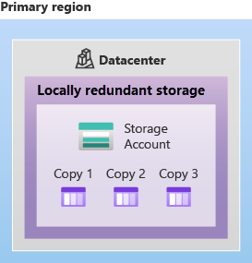

LRS is the lowest-cost redundancy option and offers the least durability compared to other options. LRS protects your data against server rack and drive failures. However, if a disaster such as fire or flooding occurs within the data center, all replicas of a storage account using LRS may be lost or unrecoverable. To mitigate this risk, Microsoft recommends using zone-redundant storage (ZRS), geo-redundant storage (GRS), or geo-zone-redundant storage (GZRS).

### Zone-redundant storage

For Availability Zone-enabled Regions, zone-redundant storage (ZRS) replicates your Azure Storage data synchronously across three Azure availability zones in the primary region. ZRS offers durability for Azure Storage data objects of at least 12 nines (99.9999999999%) over a given year.

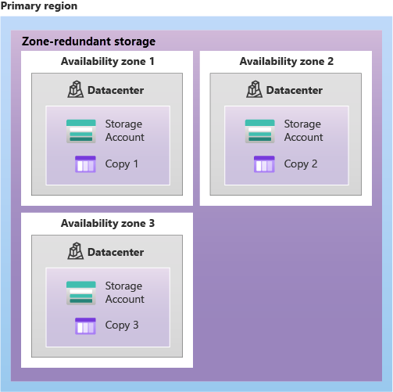

With ZRS, your data is still accessible for both read and write operations even if a zone becomes unavailable. No remounting of Azure file shares from the connected clients is required. If a zone becomes unavailable, Azure undertakes networking updates, such as DNS repointing. These updates may affect your application if you access data before the updates have completed.

Microsoft recommends using ZRS in the primary region for scenarios that require high availability. ZRS is also recommended for restricting replication of data within a country or region to meet data governance requirements.

## Redundancy in a secondary region

For applications requiring high durability, you can choose to additionally copy the data in your storage account to a secondary region that is hundreds of miles away from the primary region. If the data in your storage account is copied to a secondary region, then your data is durable even in the event of a catastrophic failure that prevents the data in the primary region from being recovered.

When you create a storage account, you select the primary region for the account. The paired secondary region is based on Azure Region Pairs, and can't be changed.

Azure Storage offers two options for copying your data to a secondary region: geo-redundant storage (GRS) and geo-zone-redundant storage (GZRS). GRS is similar to running LRS in two regions, and GZRS is similar to running ZRS in the primary region and LRS in the secondary region.

By default, data in the secondary region isn't available for read or write access unless there's a failover to the secondary region. If the primary region becomes unavailable, you can choose to fail over to the secondary region. After the failover has completed, the secondary region becomes the primary region, and you can again read and write data.

**Important**

Because data is replicated to the secondary region asynchronously, a failure that affects the primary region may result in data loss if the primary region can't be recovered. The interval between the most recent writes to the primary region and the last write to the secondary region is known as the recovery point objective (RPO). The RPO indicates the point in time to which data can be recovered. Azure Storage typically has an RPO of less than 15 minutes, although there's currently no SLA on how long it takes to replicate data to the secondary region.

### Geo-redundant storage

GRS copies your data synchronously three times within a single physical location in the primary region using LRS. It then copies your data asynchronously to a single physical location in the secondary region (the region pair) using LRS. GRS offers durability for Azure Storage data objects of at least 16 nines (99.99999999999999%) over a given year.

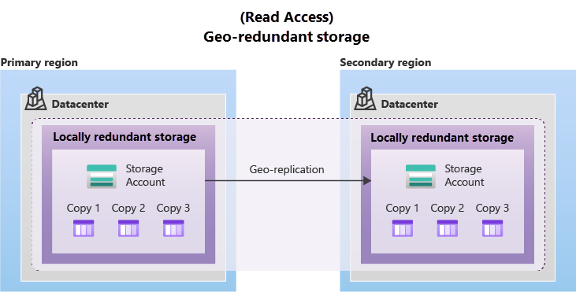

### Geo-zone-redundant storage

GZRS combines the high availability provided by redundancy across availability zones with protection from regional outages provided by geo-replication. Data in a GZRS storage account is copied across three Azure availability zones in the primary region (similar to ZRS) and is also replicated to a secondary geographic region, using LRS, for protection from regional disasters. Microsoft recommends using GZRS for applications requiring maximum consistency, durability, and availability, excellent performance, and resilience for disaster recovery.

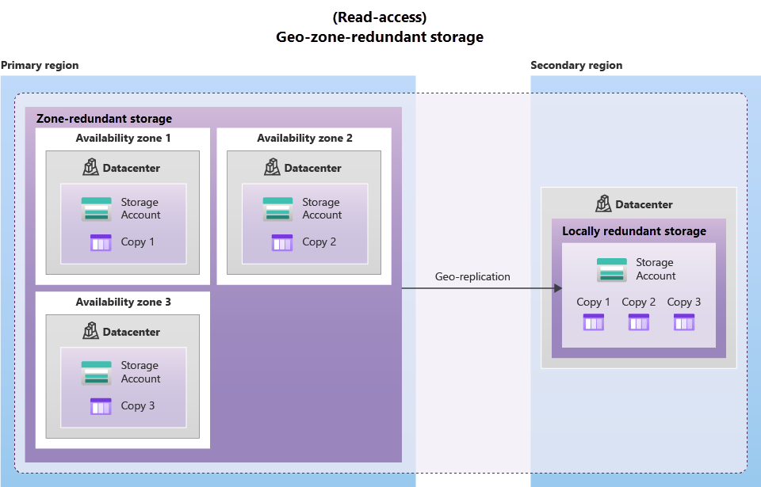

GZRS is designed to provide at least 16 nines (99.99999999999999%) of durability of objects over a given year.

## Read access to data in the secondary region

Geo-redundant storage (with GRS or GZRS) replicates your data to another physical location in the secondary region to protect against regional outages. However, that data is available to be read only if the customer or Microsoft initiates a failover from the primary to secondary region. However, if you enable read access to the secondary region, your data is always available, even when the primary region is running optimally. For read access to the secondary region, enable read-access geo-redundant storage (RA-GRS) or read-access geo-zone-redundant storage (RA-GZRS).

**Important**

Remember that the data in your secondary region may not be up-to-date due to RPO.

# Describe Azure storage services

The Azure Storage platform includes the following data services:

* **Azure Blobs**: A massively scalable object store for text and binary data. Also includes support for big data analytics through Data Lake Storage Gen2.
* **Azure Files**: Managed file shares for cloud or on-premises deployments.
* **Azure Queues**: A messaging store for reliable messaging between application components.
* **Azure Disks**: Block-level storage volumes for Azure VMs.
* **Azure Tables:** NoSQL table option for structured, non-relational data.

## Benefits of Azure Storage

Azure Storage services offer the following benefits for application developers and IT professionals:

* **Durable and highly available**. Redundancy ensures that your data is safe if transient hardware failures occur. You can also opt to replicate data across data centers or geographical regions for additional protection from local catastrophes or natural disasters. Data replicated in this way remains highly available if an unexpected outage occurs.
* **Secure**. All data written to an Azure storage account is encrypted by the service. Azure Storage provides you with fine-grained control over who has access to your data.
* **Scalable**. Azure Storage is designed to be massively scalable to meet the data storage and performance needs of today's applications.
* **Managed**. Azure handles hardware maintenance, updates, and critical issues for you.
* **Accessible**. Data in Azure Storage is accessible from anywhere in the world over HTTP or HTTPS. Microsoft provides client libraries for Azure Storage in a variety of languages, including .NET, Java, Node.js, Python, PHP, Ruby, Go, and others, as well as a mature REST API. Azure Storage supports scripting in Azure PowerShell or Azure CLI. And the Azure portal and Azure Storage Explorer offer easy visual solutions for working with your data.

## Azure Blobs

Azure Blob storage is an object storage solution for the cloud. It can store massive amounts of data, such as text or binary data. Azure Blob storage is unstructured, meaning that there are no restrictions on the kinds of data it can hold. Blob storage can manage thousands of simultaneous uploads, massive amounts of video data, constantly growing log files, and can be reached from anywhere with an internet connection.

Blobs aren't limited to common file formats. A blob could contain gigabytes of binary data streamed from a scientific instrument, an encrypted message for another application, or data in a custom format for an app you're developing. One advantage of blob storage over disk storage is that it doesn't require developers to think about or manage disks. Data is uploaded as blobs, and Azure takes care of the physical storage needs.

Blob storage is ideal for:

* Serving images or documents directly to a browser.
* Storing files for distributed access.
* Streaming video and audio.
* Storing data for backup and restore, disaster recovery, and archiving.
* Storing data for analysis by an on-premises or Azure-hosted service.

### Accessing blob storage

Objects in blob storage can be accessed from anywhere in the world via HTTP or HTTPS. Users or client applications can access blobs via URLs, the Azure Storage REST API, Azure PowerShell, Azure CLI, or an Azure Storage client library. The storage client libraries are available for multiple languages, including .NET, Java, Node.js, Python, PHP, and Ruby.

### Blob storage tiers

Data stored in the cloud can grow at an exponential pace. To manage costs for your expanding storage needs, it's helpful to organize your data based on attributes like frequency of access and planned retention period. Data stored in the cloud can be handled differently based on how it's generated, processed, and accessed over its lifetime. Some data is actively accessed and modified throughout its lifetime. Some data is accessed frequently early in its lifetime, with access dropping drastically as the data ages. Some data remains idle in the cloud and is rarely, if ever, accessed after it's stored. To accommodate these different access needs, Azure provides several access tiers, which you can use to balance your storage costs with your access needs.

Azure Storage offers different access tiers for your blob storage, helping you store object data in the most cost-effective manner. The available access tiers include:

* **Hot access tier**: Optimized for storing data that is accessed frequently (for example, images for your website).
* **Cool access tier**: Optimized for data that is infrequently accessed and stored for at least 30 days (for example, invoices for your customers).
* **Cold access tier**: Optimized for storing data that is infrequently accessed and stored for at least 90 days.
* **Archive access tier**: Appropriate for data that is rarely accessed and stored for at least 180 days, with flexible latency requirements (for example, long-term backups).

The following considerations apply to the different access tiers:

* Hot and cool access tiers can be set at the account level. The cold and archive access tiers aren't available at the account level.
* Hot, cool, cold, and archive tiers can be set at the blob level, during or after upload.
* Data in the cool and cold access tiers can tolerate slightly lower availability, but still requires high durability, retrieval latency, and throughput characteristics similar to hot data. For cool and cold data, a lower availability service-level agreement (SLA) and higher access costs compared to hot data are acceptable trade-offs for lower storage costs.
* Archive storage stores data offline and offers the lowest storage costs, but also the highest costs to rehydrate and access data.

## Azure Files

Azure File storage offers fully managed file shares in the cloud that are accessible via the industry standard Server Message Block (SMB) or Network File System (NFS) protocols. Azure Files file shares can be mounted concurrently by cloud or on-premises deployments. SMB Azure file shares are accessible from Windows, Linux, and macOS clients. NFS Azure Files shares are accessible from Linux or macOS clients. Additionally, SMB Azure file shares can be cached on Windows Servers with Azure File Sync for fast access near where the data is being used.

### Azure Files key benefits:

* **Shared access**: Azure file shares support the industry standard SMB and NFS protocols, meaning you can seamlessly replace your on-premises file shares with Azure file shares without worrying about application compatibility.
* **Fully managed**: Azure file shares can be created without the need to manage hardware or an OS. This means you don't have to deal with patching the server OS with critical security upgrades or replacing faulty hard disks.
* **Scripting and tooling**: PowerShell cmdlets and Azure CLI can be used to create, mount, and manage Azure file shares as part of the administration of Azure applications. You can create and manage Azure file shares using Azure portal and Azure Storage Explorer.
* **Resiliency**: Azure Files has been built from the ground up to always be available. Replacing on-premises file shares with Azure Files means you don't have to wake up in the middle of the night to deal with local power outages or network issues.
* **Familiar programmability**: Applications running in Azure can access data in the share via file system I/O APIs. Developers can therefore use their existing code and skills to migrate existing applications. In addition to System IO APIs, you can use Azure Storage Client Libraries or the Azure Storage REST API.

## Azure Queues

Azure Queue storage is a service for storing large numbers of messages. Once stored, you can access the messages from anywhere in the world via authenticated calls using HTTP or HTTPS. A queue can contain as many messages as your storage account has room for (potentially millions). Each individual message can be up to 64 KB in size. Queues are commonly used to create a backlog of work to process asynchronously.

Queue storage can be combined with compute functions like Azure Functions to take an action when a message is received. For example, you want to perform an action after a customer uploads a form to your website. You could have the submit button on the website trigger a message to the Queue storage. Then, you could use Azure Functions to trigger an action once the message was received.

## Azure Disks

Azure Disk storage, or Azure managed disks, are block-level storage volumes managed by Azure for use with Azure VMs. Conceptually, they’re the same as a physical disk, but they’re virtualized – offering greater resiliency and availability than a physical disk. With managed disks, all you have to do is provision the disk, and Azure will take care of the rest.

## Azure Tables

Azure Table storage stores large amounts of structured data. Azure tables are a NoSQL datastore that accepts authenticated calls from inside and outside the Azure cloud. This enables you to use Azure tables to build your hybrid or multi-cloud solution and have your data always available. Azure tables are ideal for storing structured, non-relational data.

Now that you understand the different storage options within Azure, it’s important to also understand how to get your data and information into Azure. Azure supports both real-time migration of infrastructure, applications, and data using Azure Migrate as well as asynchronous migration of data using Azure Data Box.

## Azure Migrate

Azure Migrate is a service that helps you migrate from an on-premises environment to the cloud. Azure Migrate functions as a hub to help you manage the assessment and migration of your on-premises datacenter to Azure. It provides the following:

* **Unified migration platform**: A single portal to start, run, and track your migration to Azure.
* **Range of tools**: A range of tools for assessment and migration. Azure Migrate tools include Azure Migrate: Discovery and assessment and Azure Migrate: Server Migration. Azure Migrate also integrates with other Azure services and tools, and with independent software vendor (ISV) offerings.
* **Assessment and migration**: In the Azure Migrate hub, you can assess and migrate your on-premises infrastructure to Azure.

### Integrated tools

In addition to working with tools from ISVs, the Azure Migrate hub also includes the following tools to help with migration:

* **Azure Migrate: Discovery and assessment**. Discover and assess on-premises servers running on VMware, Hyper-V, and physical servers in preparation for migration to Azure.
* **Azure Migrate: Server Migration**. Migrate VMware VMs, Hyper-V VMs, physical servers, other virtualized servers, and public cloud VMs to Azure.
* **Data Migration Assistant**. Data Migration Assistant is a stand-alone tool to assess SQL Servers. It helps pinpoint potential problems blocking migration. It identifies unsupported features, new features that can benefit you after migration, and the right path for database migration.
* **Azure Database Migration Service**. Migrate on-premises databases to Azure VMs running SQL Server, Azure SQL Database, or SQL Managed Instances.
* **Azure App Service migration assistant**. Azure App Service migration assistant is a standalone tool to assess on-premises websites for migration to Azure App Service. Use Migration Assistant to migrate .NET and PHP web apps to Azure.
* **Azure Data Box**. Use Azure Data Box products to move large amounts of offline data to Azure.

## Azure Data Box

Azure Data Box is a physical migration service that helps transfer large amounts of data in a quick, inexpensive, and reliable way. The secure data transfer is accelerated by shipping you a proprietary Data Box storage device that has a maximum usable storage capacity of 80 terabytes. The Data Box is transported to and from your datacenter via a regional carrier. A rugged case protects and secures the Data Box from damage during transit.

You can order the Data Box device via the Azure portal to import or export data from Azure. Once the device is received, you can quickly set it up using the local web UI and connect it to your network. Once you’re finished transferring the data (either into or out of Azure), simply return the Data Box. If you’re transferring data into Azure, the data is automatically uploaded once Microsoft receives the Data Box back. The entire process is tracked end-to-end by the Data Box service in the Azure portal.

### Use cases

Data Box is ideally suited to transfer data sizes larger than 40 TBs in scenarios with no to limited network connectivity. The data movement can be one-time, periodic, or an initial bulk data transfer followed by periodic transfers.

Here are the various scenarios where Data Box can be used to import data to Azure.

* Onetime migration - when a large amount of on-premises data is moved to Azure.
* Moving a media library from offline tapes into Azure to create an online media library.
* Migrating your VM farm, SQL server, and applications to Azure.
* Moving historical data to Azure for in-depth analysis and reporting using HDInsight.
* Initial bulk transfer - when an initial bulk transfer is done using Data Box (seed) followed by incremental transfers over the network.
* Periodic uploads - when large amount of data is generated periodically and needs to be moved to Azure.

Here are the various scenarios where Data Box can be used to export data from Azure.

* Disaster recovery - when a copy of the data from Azure is restored to an on-premises network. In a typical disaster recovery scenario, a large amount of Azure data is exported to a Data Box. Microsoft then ships this Data Box, and the data is restored on your premises in a short time.
* Security requirements - when you need to be able to export data out of Azure due to government or security requirements.
* Migrate back to on-premises or to another cloud service provider - when you want to move all the data back to on-premises, or to another cloud service provider, export data via Data Box to migrate the workloads.

Once the data from your import order is uploaded to Azure, the disks on the device are wiped clean in accordance with NIST 800-88r1 standards. For an export order, the disks are erased once the device reaches the Azure datacenter.

# Identify Azure file movement options

In addition to large scale migration using services like Azure Migrate and Azure Data Box, Azure also has tools designed to help you move or interact with individual files or small file groups. Among those tools are AzCopy, Azure Storage Explorer, and Azure File Sync.

## AzCopy

AzCopy is a command-line utility that you can use to copy blobs or files to or from your storage account. With AzCopy, you can upload files, download files, copy files between storage accounts, and even synchronize files. AzCopy can even be configured to work with other cloud providers to help move files back and forth between clouds.

**Important**

Synchronizing blobs or files with AzCopy is one-direction synchronization. When you synchronize, you designated the source and destination, and AzCopy will copy files or blobs in that direction. It doesn't synchronize bi-directionally based on timestamps or other metadata.

## Azure Storage Explorer

Azure Storage Explorer is a standalone app that provides a graphical interface to manage files and blobs in your Azure Storage Account. It works on Windows, macOS, and Linux operating systems and uses AzCopy on the backend to perform all of the file and blob management tasks. With Storage Explorer, you can upload to Azure, download from Azure, or move between storage accounts.

## Azure File Sync

Azure File Sync is a tool that lets you centralize your file shares in Azure Files and keep the flexibility, performance, and compatibility of a Windows file server. It’s almost like turning your Windows file server into a miniature content delivery network. Once you install Azure File Sync on your local Windows server, it will automatically stay bi-directionally synced with your files in Azure.

With Azure File Sync, you can:

* Use any protocol that's available on Windows Server to access your data locally, including SMB, NFS, and FTPS.
* Have as many caches as you need across the world.
* Replace a failed local server by installing Azure File Sync on a new server in the same datacenter.
* Configure cloud tiering so the most frequently accessed files are replicated locally, while infrequently accessed files are kept in the cloud until requested.

# Describe Azure directory services

Microsoft Entra ID is a directory service that enables you to sign in and access both Microsoft cloud applications and cloud applications that you develop. Microsoft Entra ID can also help you maintain your on-premises Active Directory deployment.

For on-premises environments, Active Directory running on Windows Server provides an identity and access management service that's managed by your organization. Microsoft Entra ID is Microsoft's cloud-based identity and access management service. With Microsoft Entra ID, you control the identity accounts, but Microsoft ensures that the service is available globally. If you've worked with Active Directory, Microsoft Entra ID will be familiar to you.

When you secure identities on-premises with Active Directory, Microsoft doesn't monitor sign-in attempts. When you connect Active Directory with Microsoft Entra ID, Microsoft can help protect you by detecting suspicious sign-in attempts at no extra cost. For example, Microsoft Entra ID can detect sign-in attempts from unexpected locations or unknown devices.

## Who uses Microsoft Entra ID?

Microsoft Entra ID is for:

* **IT administrators**. Administrators can use Microsoft Entra ID to control access to applications and resources based on their business requirements.
* **App developers**. Developers can use Microsoft Entra ID to provide a standards-based approach for adding functionality to applications that they build, such as adding SSO functionality to an app or enabling an app to work with a user's existing credentials.
* **Users**. Users can manage their identities and take maintenance actions like self-service password reset.
* **Online service subscribers**. Microsoft 365, Microsoft Office 365, Azure, and Microsoft Dynamics CRM Online subscribers are already using Microsoft Entra ID to authenticate into their account.

## What does Microsoft Entra ID do?

Microsoft Entra ID provides services such as:

* **Authentication**: This includes verifying identity to access applications and resources. It also includes providing functionality such as self-service password reset, multifactor authentication, a custom list of banned passwords, and smart lockout services.
* **Single sign-on**: Single sign-on (SSO) enables you to remember only one username and one password to access multiple applications. A single identity is tied to a user, which simplifies the security model. As users change roles or leave an organization, access modifications are tied to that identity, which greatly reduces the effort needed to change or disable accounts.
* **Application management**: You can manage your cloud and on-premises apps by using Microsoft Entra ID. Features like Application Proxy, SaaS apps, the My Apps portal, and single sign-on provide a better user experience.
* **Device management**: Along with accounts for individual people, Microsoft Entra ID supports the registration of devices. Registration enables devices to be managed through tools like Microsoft Intune. It also allows for device-based Conditional Access policies to restrict access attempts to only those coming from known devices, regardless of the requesting user account.

## Can I connect my on-premises AD with Microsoft Entra ID?

If you had an on-premises environment running Active Directory and a cloud deployment using Microsoft Entra ID, you would need to maintain two identity sets. However, you can connect Active Directory with Microsoft Entra ID, enabling a consistent identity experience between cloud and on-premises.

One method of connecting Microsoft Entra ID with your on-premises AD is using Microsoft Entra Connect. Microsoft Entra Connect synchronizes user identities between on-premises Active Directory and Microsoft Entra ID. Microsoft Entra Connect synchronizes changes between both identity systems, so you can use features like SSO, multifactor authentication, and self-service password reset under both systems.

## What is Microsoft Entra Domain Services?

Microsoft Entra Domain Services is a service that provides managed domain services such as domain join, group policy, lightweight directory access protocol (LDAP), and Kerberos/NTLM authentication. Just like Microsoft Entra ID lets you use directory services without having to maintain the infrastructure supporting it, with Microsoft Entra Domain Services, you get the benefit of domain services without the need to deploy, manage, and patch domain controllers (DCs) in the cloud.

A Microsoft Entra Domain Services managed domain lets you run legacy applications in the cloud that can't use modern authentication methods, or where you don't want directory lookups to always go back to an on-premises AD DS environment. You can lift and shift those legacy applications from your on-premises environment into a managed domain, without needing to manage the AD DS environment in the cloud.

Microsoft Entra Domain Services integrates with your existing Microsoft Entra tenant. This integration lets users sign into services and applications connected to the managed domain using their existing credentials. You can also use existing groups and user accounts to secure access to resources. These features provide a smoother lift-and-shift of on-premises resources to Azure.

### How does Microsoft Entra Domain Services work?

When you create a Microsoft Entra Domain Services managed domain, you define a unique namespace. This namespace is the domain name. Two Windows Server domain controllers are then deployed into your selected Azure region. This deployment of DCs is known as a replica set.

You don't need to manage, configure, or update these DCs. The Azure platform handles the DCs as part of the managed domain, including backups and encryption at rest using Azure Disk Encryption.

### Is information synchronized?

A managed domain is configured to perform a one-way synchronization from Microsoft Entra ID to Microsoft Entra Domain Services. You can create resources directly in the managed domain, but they aren't synchronized back to Microsoft Entra ID. In a hybrid environment with an on-premises AD DS environment, Microsoft Entra Connect synchronizes identity information with Microsoft Entra ID, which is then synchronized to the managed domain.

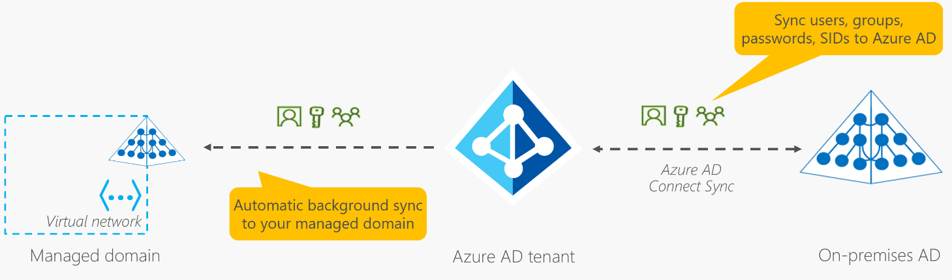

Applications, services, and VMs in Azure that connect to the managed domain can then use common Microsoft Entra Domain Services features such as domain join, group policy, LDAP, and Kerberos/NTLM authentication.

# Describe Azure authentication methods

Authentication is the process of establishing the identity of a person, service, or device. It requires the person, service, or device to provide some type of credential to prove who they are. Authentication is like presenting ID when you’re traveling. It doesn’t confirm that you’re ticketed, it just proves that you're who you say you are. Azure supports multiple authentication methods, including standard passwords, single sign-on (SSO), multifactor authentication (MFA), and passwordless.

For the longest time, security and convenience seemed to be at odds with each other. Thankfully, new authentication solutions provide both security and convenience.

The following diagram shows the security level compared to the convenience. Notice Passwordless authentication is high security and high convenience while passwords on their own are low security but high convenience.

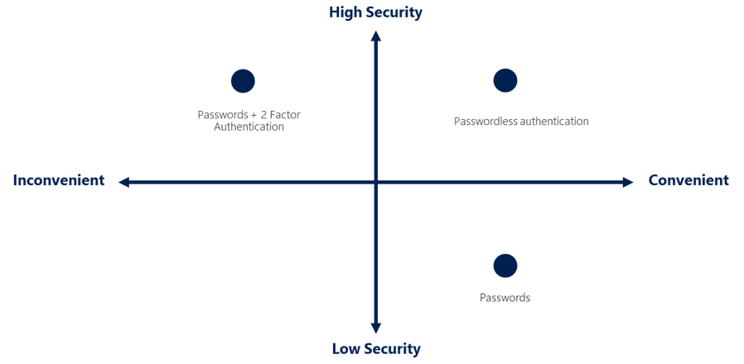

## What's single sign-on?

Single sign-on (SSO) enables a user to sign in one time and use that credential to access multiple resources and applications from different providers. For SSO to work, the different applications and providers must trust the initial authenticator.

More identities mean more passwords to remember and change. Password policies can vary among applications. As complexity requirements increase, it becomes increasingly difficult for users to remember them. The more passwords a user has to manage, the greater the risk of a credential-related security incident.

Consider the process of managing all those identities. More strain is placed on help desks as they deal with account lockouts and password reset requests. If a user leaves an organization, tracking down all those identities and ensuring they're disabled can be challenging. If an identity is overlooked, this might allow access when it should have been eliminated.

With SSO, you need to remember only one ID and one password. Access across applications is granted to a single identity that's tied to the user, which simplifies the security model. As users change roles or leave an organization, access is tied to a single identity. This change greatly reduces the effort needed to change or disable accounts. Using SSO for accounts makes it easier for users to manage their identities and for IT to manage users.

**Important**

Single sign-on is only as secure as the initial authenticator because the subsequent connections are all based on the security of the initial authenticator.

## What’s multifactor authentication?

Multifactor authentication is the process of prompting a user for an extra form (or factor) of identification during the sign-in process. MFA helps protect against a password compromise in situations where the password was compromised but the second factor wasn't.

Think about how you sign into websites, email, or online services. After entering your username and password, have you ever needed to enter a code that was sent to your phone? If so, you've used multifactor authentication to sign in.

Multifactor authentication provides additional security for your identities by requiring two or more elements to fully authenticate. These elements fall into three categories:

* Something the user knows – this might be a challenge question.
* Something the user has – this might be a code that's sent to the user's mobile phone.
* Something the user is – this is typically some sort of biometric property, such as a fingerprint or face scan.

Multifactor authentication increases identity security by limiting the impact of credential exposure (for example, stolen usernames and passwords). With multifactor authentication enabled, an attacker who has a user's password would also need to have possession of their phone or their fingerprint to fully authenticate.

Compare multifactor authentication with single-factor authentication. Under single-factor authentication, an attacker would need only a username and password to authenticate. Multifactor authentication should be enabled wherever possible because it adds enormous benefits to security.

### What's Microsoft Entra multifactor authentication?

Microsoft Entra multifactor authentication is a Microsoft service that provides multifactor authentication capabilities. Microsoft Entra multifactor authentication enables users to choose an additional form of authentication during sign-in, such as a phone call or mobile app notification.

## What’s passwordless authentication?

Features like MFA are a great way to secure your organization, but users often get frustrated with the additional security layer on top of having to remember their passwords. People are more likely to comply when it's easy and convenient to do so. Passwordless authentication methods are more convenient because the password is removed and replaced with something you have, plus something you are, or something you know.

Passwordless authentication needs to be set up on a device before it can work. For example, your computer is something you have. Once it’s been registered or enrolled, Azure now knows that it’s associated with you. Now that the computer is known, once you provide something you know or are (such as a PIN or fingerprint), you can be authenticated without using a password.

Each organization has different needs when it comes to authentication. Microsoft global Azure and Azure Government offer the following three passwordless authentication options that integrate with Microsoft Entra ID:

* Windows Hello for Business
* Microsoft Authenticator app
* FIDO2 security keys

### Windows Hello for Business

Windows Hello for Business is ideal for information workers that have their own designated Windows PC. The biometric and PIN credentials are directly tied to the user's PC, which prevents access from anyone other than the owner. With public key infrastructure (PKI) integration and built-in support for single sign-on (SSO), Windows Hello for Business provides a convenient method for seamlessly accessing corporate resources on-premises and in the cloud.

### Microsoft Authenticator App

You can also allow your employee's phone to become a passwordless authentication method. You may already be using the Microsoft Authenticator App as a convenient multifactor authentication option in addition to a password. You can also use the Authenticator App as a passwordless option.

The Authenticator App turns any iOS or Android phone into a strong, passwordless credential. Users can sign-in to any platform or browser by getting a notification to their phone, matching a number displayed on the screen to the one on their phone, and then using their biometric (touch or face) or PIN to confirm. Refer to Download and install the Microsoft Authenticator app for installation details.

### FIDO2 security keys

The FIDO (Fast IDentity Online) Alliance helps to promote open authentication standards and reduce the use of passwords as a form of authentication. FIDO2 is the latest standard that incorporates the web authentication (WebAuthn) standard.

FIDO2 security keys are an unphishable standards-based passwordless authentication method that can come in any form factor. Fast Identity Online (FIDO) is an open standard for passwordless authentication. FIDO allows users and organizations to leverage the standard to sign-in to their resources without a username or password by using an external security key or a platform key built into a device.

Users can register and then select a FIDO2 security key at the sign-in interface as their main means of authentication. These FIDO2 security keys are typically USB devices, but could also use Bluetooth or NFC. With a hardware device that handles the authentication, the security of an account is increased as there's no password that could be exposed or guessed.

**Describe Azure external identities**

An external identity is a person, device, service, etc. that is outside your organization. Microsoft Entra External ID refers to all the ways you can securely interact with users outside of your organization. If you want to collaborate with partners, distributors, suppliers, or vendors, you can share your resources and define how your internal users can access external organizations. If you're a developer creating consumer-facing apps, you can manage your customers' identity experiences.

External identities may sound similar to single sign-on. With External Identities, external users can "bring their own identities." Whether they have a corporate or government-issued digital identity, or an unmanaged social identity like Google or Facebook, they can use their own credentials to sign in. The external user’s identity provider manages their identity, and you manage access to your apps with Microsoft Entra ID or Azure AD B2C to keep your resources protected.

The following capabilities make up External Identities:

* **Business to business (B2B) collaboration** - Collaborate with external users by letting them use their preferred identity to sign-in to your Microsoft applications or other enterprise applications (SaaS apps, custom-developed apps, etc.). B2B collaboration users are represented in your directory, typically as guest users.
* **B2B direct connect** - Establish a mutual, two-way trust with another Microsoft Entra organization for seamless collaboration. B2B direct connect currently supports Teams shared channels, enabling external users to access your resources from within their home instances of Teams. B2B direct connect users aren't represented in your directory, but they're visible from within the Teams shared channel and can be monitored in Teams admin center reports.
* **Microsoft Azure Active Directory business to customer (B2C)** - Publish modern SaaS apps or custom-developed apps (excluding Microsoft apps) to consumers and customers, while using Azure AD B2C for identity and access management.

Depending on how you want to interact with external organizations and the types of resources you need to share, you can use a combination of these capabilities.

With Microsoft Entra ID, you can easily enable collaboration across organizational boundaries by using the Microsoft Entra B2B feature. Guest users from other tenants can be invited by administrators or by other users. This capability also applies to social identities such as Microsoft accounts.

You also can easily ensure that guest users have appropriate access. You can ask the guests themselves or a decision maker to participate in an access review and recertify (or attest) to the guests' access. The reviewers can give their input on each user's need for continued access, based on suggestions from Microsoft Entra ID. When an access review is finished, you can then make changes and remove access for guests who no longer need it.

# Describe Azure conditional access

Conditional Access is a tool that Microsoft Entra ID uses to allow (or deny) access to resources based on identity signals. These signals include who the user is, where the user is, and what device the user is requesting access from.

Conditional Access helps IT administrators:

* Empower users to be productive wherever and whenever.
* Protect the organization's assets.

Conditional Access also provides a more granular multifactor authentication experience for users. For example, a user might not be challenged for second authentication factor if they're at a known location. However, they might be challenged for a second authentication factor if their sign-in signals are unusual or they're at an unexpected location.

During sign-in, Conditional Access collects signals from the user, makes decisions based on those signals, and then enforces that decision by allowing or denying the access request or challenging for a multifactor authentication response.

The following diagram illustrates this flow:

Here, the signal might be the user's location, the user's device, or the application that the user is trying to access.

Based on these signals, the decision might be to allow full access if the user is signing in from their usual location. If the user is signing in from an unusual location or a location that's marked as high risk, then access might be blocked entirely or possibly granted after the user provides a second form of authentication.

Enforcement is the action that carries out the decision. For example, the action is to allow access or require the user to provide a second form of authentication.

## When can I use Conditional Access?

Conditional Access is useful when you need to:

* Require multifactor authentication (MFA) to access an application depending on the requester’s role, location, or network. For example, you could require MFA for administrators but not regular users or for people connecting from outside your corporate network.
* Require access to services only through approved client applications. For example, you could limit which email applications are able to connect to your email service.
* Require users to access your application only from managed devices. A managed device is a device that meets your standards for security and compliance.
* Block access from untrusted sources, such as access from unknown or unexpected locations.

# Describe Azure role-based access control

When you have multiple IT and engineering teams, how can you control what access they have to the resources in your cloud environment? The principle of least privilege says you should only grant access up to the level needed to complete a task. If you only need read access to a storage blob, then you should only be granted read access to that storage blob. Write access to that blob shouldn’t be granted, nor should read access to other storage blobs. It’s a good security practice to follow.

However, managing that level of permissions for an entire team would become tedious. Instead of defining the detailed access requirements for each individual, and then updating access requirements when new resources are created or new people join the team, Azure enables you to control access through Azure role-based access control (Azure RBAC).

Azure provides built-in roles that describe common access rules for cloud resources. You can also define your own roles. Each role has an associated set of access permissions that relate to that role. When you assign individuals or groups to one or more roles, they receive all the associated access permissions.

So, if you hire a new engineer and add them to the Azure RBAC group for engineers, they automatically get the same access as the other engineers in the same Azure RBAC group. Similarly, if you add additional resources and point Azure RBAC at them, everyone in that Azure RBAC group will now have those permissions on the new resources as well as the existing resources.

## How is role-based access control applied to resources?

Role-based access control is applied to a scope, which is a resource or set of resources that this access applies to.

The following diagram shows the relationship between roles and scopes. A management group, subscription, or resource group might be given the role of owner, so they have increased control and authority. An observer, who isn't expected to make any updates, might be given a role of Reader for the same scope, enabling them to review or observe the management group, subscription, or resource group.

Scopes include:

* A management group (a collection of multiple subscriptions).
* A single subscription.
* A resource group.
* A single resource.

Observers, users managing resources, admins, and automated processes illustrate the kinds of users or accounts that would typically be assigned each of the various roles.

Azure RBAC is hierarchical, in that when you grant access at a parent scope, those permissions are inherited by all child scopes. For example:

* When you assign the Owner role to a user at the management group scope, that user can manage everything in all subscriptions within the management group.
* When you assign the Reader role to a group at the subscription scope, the members of that group can view every resource group and resource within the subscription.

## How is Azure RBAC enforced?

Azure RBAC is enforced on any action that's initiated against an Azure resource that passes through Azure Resource Manager. Resource Manager is a management service that provides a way to organize and secure your cloud resources.

You typically access Resource Manager from the Azure portal, Azure Cloud Shell, Azure PowerShell, and the Azure CLI. Azure RBAC doesn't enforce access permissions at the application or data level. Application security must be handled by your application.

Azure RBAC uses an allow model. When you're assigned a role, Azure RBAC allows you to perform actions within the scope of that role. If one role assignment grants you read permissions to a resource group and a different role assignment grants you write permissions to the same resource group, you have both read and write permissions on that resource group.

# Describe zero trust model

Zero Trust is a security model that assumes the worst case scenario and protects resources with that expectation. Zero Trust assumes breach at the outset, and then verifies each request as though it originated from an uncontrolled network.

Today, organizations need a new security model that effectively adapts to the complexity of the modern environment; embraces the mobile workforce; and protects people, devices, applications, and data wherever they're located.

To address this new world of computing, Microsoft highly recommends the Zero Trust security model, which is based on these guiding principles:

* **Verify explicitly** - Always authenticate and authorize based on all available data points.
* **Use least privilege access** - Limit user access with Just-In-Time and Just-Enough-Access (JIT/JEA), risk-based adaptive policies, and data protection.
* **Assume breach** - Minimize blast radius and segment access. Verify end-to-end encryption. Use analytics to get visibility, drive threat detection, and improve defenses.

## Adjusting to Zero Trust

Traditionally, corporate networks were restricted, protected, and generally assumed safe. Only managed computers could join the network, VPN access was tightly controlled, and personal devices were frequently restricted or blocked.

The Zero Trust model flips that scenario. Instead of assuming that a device is safe because it’s within the corporate network, it requires everyone to authenticate. Then grants access based on authentication rather than location.

# Describe defense-in-depth

The objective of defense-in-depth is to protect information and prevent it from being stolen by those who aren't authorized to access it.

A defense-in-depth strategy uses a series of mechanisms to slow the advance of an attack that aims at acquiring unauthorized access to data.

## Layers of defense-in-depth

You can visualize defense-in-depth as a set of layers, with the data to be secured at the center and all the other layers functioning to protect that central data layer.

Each layer provides protection so that if one layer is breached, a subsequent layer is already in place to prevent further exposure. This approach removes reliance on any single layer of protection. It slows down an attack and provides alert information that security teams can act upon, either automatically or manually.

Here's a brief overview of the role of each layer:

* The physical security layer is the first line of defense to protect computing hardware in the datacenter.
* The identity and access layer controls access to infrastructure and change control.
* The perimeter layer uses distributed denial of service (DDoS) protection to filter large-scale attacks before they can cause a denial of service for users.
* The network layer limits communication between resources through segmentation and access controls.
* The compute layer secures access to virtual machines.
* The application layer helps ensure that applications are secure and free of security vulnerabilities.
* The data layer controls access to business and customer data that you need to protect.

These layers provide a guideline for you to help make security configuration decisions in all of the layers of your applications.

Azure provides security tools and features at every level of the defense-in-depth concept. Let's take a closer look at each layer:

### Physical security

Physically securing access to buildings and controlling access to computing hardware within the datacenter are the first line of defense.

With physical security, the intent is to provide physical safeguards against access to assets. These safeguards ensure that other layers can't be bypassed, and loss or theft is handled appropriately. Microsoft uses various physical security mechanisms in its cloud datacenters.

### Identity and access

The identity and access layer is all about ensuring that identities are secure, that access is granted only to what's needed, and that sign-in events and changes are logged.

At this layer, it's important to:

* Control access to infrastructure and change control.
* Use single sign-on (SSO) and multifactor authentication.
* Audit events and changes.

### Perimeter

The network perimeter protects from network-based attacks against your resources. Identifying these attacks, eliminating their impact, and alerting you when they happen are important ways to keep your network secure.

At this layer, it's important to:

* Use DDoS protection to filter large-scale attacks before they can affect the availability of a system for users.
* Use perimeter firewalls to identify and alert on malicious attacks against your network.

### Network

At this layer, the focus is on limiting the network connectivity across all your resources to allow only what's required. By limiting this communication, you reduce the risk of an attack spreading to other systems in your network.

At this layer, it's important to:

* Limit communication between resources.
* Deny by default.
* Restrict inbound internet access and limit outbound access where appropriate.
* Implement secure connectivity to on-premises networks.

### Compute

Malware, unpatched systems, and improperly secured systems open your environment to attacks. The focus in this layer is on making sure that your compute resources are secure and that you have the proper controls in place to minimize security issues.

At this layer, it's important to:

* Secure access to virtual machines.
* Implement endpoint protection on devices and keep systems patched and current.

### Application

Integrating security into the application development lifecycle helps reduce the number of vulnerabilities introduced in code. Every development team should ensure that its applications are secure by default.

At this layer, it's important to:

* Ensure that applications are secure and free of vulnerabilities.
* Store sensitive application secrets in a secure storage medium.
* Make security a design requirement for all application development.

### Data

Those who store and control access to data are responsible for ensuring that it's properly secured. Often, regulatory requirements dictate the controls and processes that must be in place to ensure the confidentiality, integrity, and availability of the data.

In almost all cases, attackers are after data:

* Stored in a database.
* Stored on disk inside virtual machines.
* Stored in software as a service (SaaS) applications, such as Office 365.
* Managed through cloud storage.

# Describe Microsoft Defender for Cloud

Defender for Cloud is a monitoring tool for security posture management and threat protection. It monitors your cloud, on-premises, hybrid, and multi-cloud environments to provide guidance and notifications aimed at strengthening your security posture.

Defender for Cloud provides the tools needed to harden your resources, track your security posture, protect against cyber attacks, and streamline security management. Deployment of Defender for Cloud is easy, it’s already natively integrated to Azure.

## Protection everywhere you’re deployed

Because Defender for Cloud is an Azure-native service, many Azure services are monitored and protected without needing any deployment. However, if you also have an on-premises datacenter or are also operating in another cloud environment, monitoring of Azure services may not give you a complete picture of your security situation.

When necessary, Defender for Cloud can automatically deploy a Log Analytics agent to gather security-related data. For Azure machines, deployment is handled directly. For hybrid and multi-cloud environments, Microsoft Defender plans are extended to non Azure machines with the help of Azure Arc. Cloud security posture management (CSPM) features are extended to multi-cloud machines without the need for any agents.

### Azure-native protections

Defender for Cloud helps you detect threats across:

* Azure PaaS services – Detect threats targeting Azure services including Azure App Service, Azure SQL, Azure Storage Account, and more data services. You can also perform anomaly detection on your Azure activity logs using the native integration with Microsoft Defender for Cloud Apps (formerly known as Microsoft Cloud App Security).
* Azure data services – Defender for Cloud includes capabilities that help you automatically classify your data in Azure SQL. You can also get assessments for potential vulnerabilities across Azure SQL and Storage services, and recommendations for how to mitigate them.
* Networks – Defender for Cloud helps you limit exposure to brute force attacks. By reducing access to virtual machine ports, using the just-in-time VM access, you can harden your network by preventing unnecessary access. You can set secure access policies on selected ports, for only authorized users, allowed source IP address ranges or IP addresses, and for a limited amount of time.

### Defend your hybrid resources

In addition to defending your Azure environment, you can add Defender for Cloud capabilities to your hybrid cloud environment to protect your non-Azure servers. To help you focus on what matters the most, you'll get customized threat intelligence and prioritized alerts according to your specific environment.

To extend protection to on-premises machines, deploy Azure Arc and enable Defender for Cloud's enhanced security features.

### Defend resources running on other clouds

Defender for Cloud can also protect resources in other clouds (such as AWS and GCP).

For example, if you've connected an Amazon Web Services (AWS) account to an Azure subscription, you can enable any of these protections:

* Defender for Cloud's CSPM features extend to your AWS resources. This agentless plan assesses your AWS resources according to AWS-specific security recommendations, and includes the results in the secure score. The resources will also be assessed for compliance with built-in standards specific to AWS (AWS CIS, AWS PCI DSS, and AWS Foundational Security Best Practices). Defender for Cloud's asset inventory page is a multi-cloud enabled feature helping you manage your AWS resources alongside your Azure resources.
* Microsoft Defender for Containers extends its container threat detection and advanced defenses to your Amazon EKS Linux clusters.
* Microsoft Defender for Servers brings threat detection and advanced defenses to your Windows and Linux EC2 instances.

## Assess, Secure, and Defend

Defender for Cloud fills three vital needs as you manage the security of your resources and workloads in the cloud and on-premises:

* Continuously assess – Know your security posture. Identify and track vulnerabilities.
* Secure – Harden resources and services with Azure Security Benchmark.
* Defend – Detect and resolve threats to resources, workloads, and services.

### Continuously assess

Defender for cloud helps you continuously assess your environment. Defender for Cloud includes vulnerability assessment solutions for your virtual machines, container registries, and SQL servers.

Microsoft Defender for servers includes automatic, native integration with Microsoft Defender for Endpoint. With this integration enabled, you'll have access to the vulnerability findings from Microsoft threat and vulnerability management.

Between these assessment tools you’ll have regular, detailed vulnerability scans that cover your compute, data, and infrastructure. You can review and respond to the results of these scans all from within Defender for Cloud.

### Secure

From authentication methods to access control to the concept of Zero Trust, security in the cloud is an essential basic that must be done right. In order to be secure in the cloud, you have to ensure your workloads are secure. To secure your workloads, you need security policies in place that are tailored to your environment and situation. Because policies in Defender for Cloud are built on top of Azure Policy controls, you're getting the full range and flexibility of a world-class policy solution. In Defender for Cloud, you can set your policies to run on management groups, across subscriptions, and even for a whole tenant.

One of the benefits of moving to the cloud is the ability to grow and scale as you need, adding new services and resources as necessary. Defender for Cloud is constantly monitoring for new resources being deployed across your workloads. Defender for Cloud assesses if new resources are configured according to security best practices. If not, they're flagged and you get a prioritized list of recommendations for what you need to fix. Recommendations help you reduce the attack surface across each of your resources.

The list of recommendations is enabled and supported by the Azure Security Benchmark. This Microsoft-authored, Azure-specific, benchmark provides a set of guidelines for security and compliance best practices based on common compliance frameworks.

In this way, Defender for Cloud enables you not just to set security policies, but to apply secure configuration standards across your resources.

To help you understand how important each recommendation is to your overall security posture, Defender for Cloud groups the recommendations into security controls and adds a secure score value to each control. The secure score gives you an at-a-glance indicator of the health of your security posture, while the controls give you a working list of things to consider to improve your security score and your overall security posture.

### Defend

The first two areas were focused on assessing, monitoring, and maintaining your environment. Defender for Cloud also helps you defend your environment by providing security alerts and advanced threat protection features.

#### Security alerts

When Defender for Cloud detects a threat in any area of your environment, it generates a security alert. Security alerts:

* Describe details of the affected resources
* Suggest remediation steps
* Provide, in some cases, an option to trigger a logic app in response

Whether an alert is generated by Defender for Cloud or received by Defender for Cloud from an integrated security product, you can export it. Defender for Cloud's threat protection includes fusion kill-chain analysis, which automatically correlates alerts in your environment based on cyber kill-chain analysis, to help you better understand the full story of an attack campaign, where it started, and what kind of impact it had on your resources.

#### Advanced threat protection

Defender for cloud provides advanced threat protection features for many of your deployed resources, including virtual machines, SQL databases, containers, web applications, and your network. Protections include securing the management ports of your VMs with just-in-time access, and adaptive application controls to create allowlists for what apps should and shouldn't run on your machines.

The following video provides an introduction to things that can impact your costs in Azure.

Azure shifts development costs from the capital expense (CapEx) of building out and maintaining infrastructure and facilities to an operational expense (OpEx) of renting infrastructure as you need it, whether it’s compute, storage, networking, and so on.

That OpEx cost can be impacted by many factors. Some of the impacting factors are:

* Resource type
* Consumption
* Maintenance
* Geography
* Subscription type
* Azure Marketplace

## Resource type

A number of factors influence the cost of Azure resources. The type of resources, the settings for the resource, and the Azure region will all have an impact on how much a resource costs. When you provision an Azure resource, Azure creates metered instances for that resource. The meters track the resources' usage and generate a usage record that is used to calculate your bill.

### Examples

With a storage account, you specify a type such as blob, a performance tier, an access tier, redundancy settings, and a region. Creating the same storage account in different regions may show different costs and changing any of the settings may also impact the price.

With a virtual machine (VM), you may have to consider licensing for the operating system or other software, the processor and number of cores for the VM, the attached storage, and the network interface. Just like with storage, provisioning the same virtual machine in different regions may result in different costs.

## Consumption

Pay-as-you-go has been a consistent theme throughout, and that’s the cloud payment model where you pay for the resources that you use during a billing cycle. If you use more compute this cycle, you pay more. If you use less in the current cycle, you pay less. It’s a straight forward pricing mechanism that allows for maximum flexibility.

However, Azure also offers the ability to commit to using a set amount of cloud resources in advance and receiving discounts on those “reserved” resources. Many services, including databases, compute, and storage all provide the option to commit to a level of use and receive a discount, in some cases up to 72 percent.

When you reserve capacity, you’re committing to using and paying for a certain amount of Azure resources during a given period (typically one or three years). With the back-up of pay-as-you-go, if you see a sudden surge in demand that eclipses what you’ve pre-reserved, you just pay for the additional resources in excess of your reservation. This model allows you to recognize significant savings on reliable, consistent workloads while also having the flexibility to rapidly increase your cloud footprint as the need arises.

## Maintenance

The flexibility of the cloud makes it possible to rapidly adjust resources based on demand. Using resource groups can help keep all of your resources organized. In order to control costs, it’s important to maintain your cloud environment. For example, every time you provision a VM, additional resources such as storage and networking are also provisioned. If you deprovision the VM, those additional resources may not deprovision at the same time, either intentionally or unintentionally. By keeping an eye on your resources and making sure you’re not keeping around resources that are no longer needed, you can help control cloud costs.

## Geography

When you provision most resources in Azure, you need to define a region where the resource deploys. Azure infrastructure is distributed globally, which enables you to deploy your services centrally or closest to your customers, or something in between. With this global deployment comes global pricing differences. The cost of power, labor, taxes, and fees vary depending on the location. Due to these variations, Azure resources can differ in costs to deploy depending on the region.

Network traffic is also impacted based on geography. For example, it’s less expensive to move information within Europe than to move information from Europe to Asia or South America.

### Network Traffic

Billing zones are a factor in determining the cost of some Azure services.

Bandwidth refers to data moving in and out of Azure datacenters. Some inbound data transfers (data going into Azure datacenters) are free. For outbound data transfers (data leaving Azure datacenters), data transfer pricing is based on zones.

A zone is a geographical grouping of Azure regions for billing purposes. The [bandwidth pricing page](https://azure.microsoft.com/pricing/details/bandwidth/) has additional information on pricing for data ingress, egress, and transfer.

## Subscription type

Some Azure subscription types also include usage allowances, which affect costs.

For example, an Azure free trial subscription provides access to a number of Azure products that are free for 12 months. It also includes credit to spend within your first 30 days of sign-up. You'll get access to more than 25 products that are always free (based on resource and region availability).

## Azure Marketplace

Azure Marketplace lets you purchase Azure-based solutions and services from third-party vendors. This could be a server with software preinstalled and configured, or managed network firewall appliances, or connectors to third-party backup services. When you purchase products through Azure Marketplace, you may pay for not only the Azure services that you’re using, but also the services or expertise of the third-party vendor. Billing structures are set by the vendor.

All solutions available in Azure Marketplace are certified and compliant with Azure policies and standards. The certification policies may vary based on the service or solution type and Azure service involved. [Commercial marketplace certification policies](https://learn.microsoft.com/en-us/legal/marketplace/certification-policies) has additional information on Azure Marketplace certifications.

# Compare the Pricing and Total Cost of Ownership calculators

The pricing calculator and the total cost of ownership (TCO) calculator are two calculators that help you understand potential Azure expenses. Both calculators are accessible from the internet, and both calculators allow you to build out a configuration. However, the two calculators have very different purposes.

## Pricing calculator

The pricing calculator is designed to give you an estimated cost for provisioning resources in Azure. You can get an estimate for individual resources, build out a solution, or use an example scenario to see an estimate of the Azure spend. The pricing calculator’s focus is on the cost of provisioned resources in Azure.

**Note**

The Pricing calculator is for information purposes only. The prices are only an estimate. Nothing is provisioned when you add resources to the pricing calculator, and you won't be charged for any services you select.

With the pricing calculator, you can estimate the cost of any provisioned resources, including compute, storage, and associated network costs. You can even account for different storage options like storage type, access tier, and redundancy.

## TCO calculator

The TCO calculator is designed to help you compare the costs for running an on-premises infrastructure compared to an Azure Cloud infrastructure. With the TCO calculator, you enter your current infrastructure configuration, including servers, databases, storage, and outbound network traffic. The TCO calculator then compares the anticipated costs for your current environment with an Azure environment supporting the same infrastructure requirements.

With the TCO calculator, you enter your configuration, add in assumptions like power and IT labor costs, and are presented with an estimation of the cost difference to run the same environment in your current datacenter or in Azure.

# Describe the Microsoft Cost Management tool

Microsoft Azure is a global cloud provider, meaning you can provision resources anywhere in the world. You can provision resources rapidly to meet a sudden demand, or to test out a new feature, or on accident. If you accidentally provision new resources, you may not be aware of them until it’s time for your invoice. Cost Management is a service that helps avoid those situations.

## What is Cost Management?

Cost Management provides the ability to quickly check Azure resource costs, create alerts based on resource spend, and create budgets that can be used to automate management of resources.

Cost analysis is a subset of Cost Management that provides a quick visual for your Azure costs. Using cost analysis, you can quickly view the total cost in a variety of different ways, including by billing cycle, region, resource, and so on.

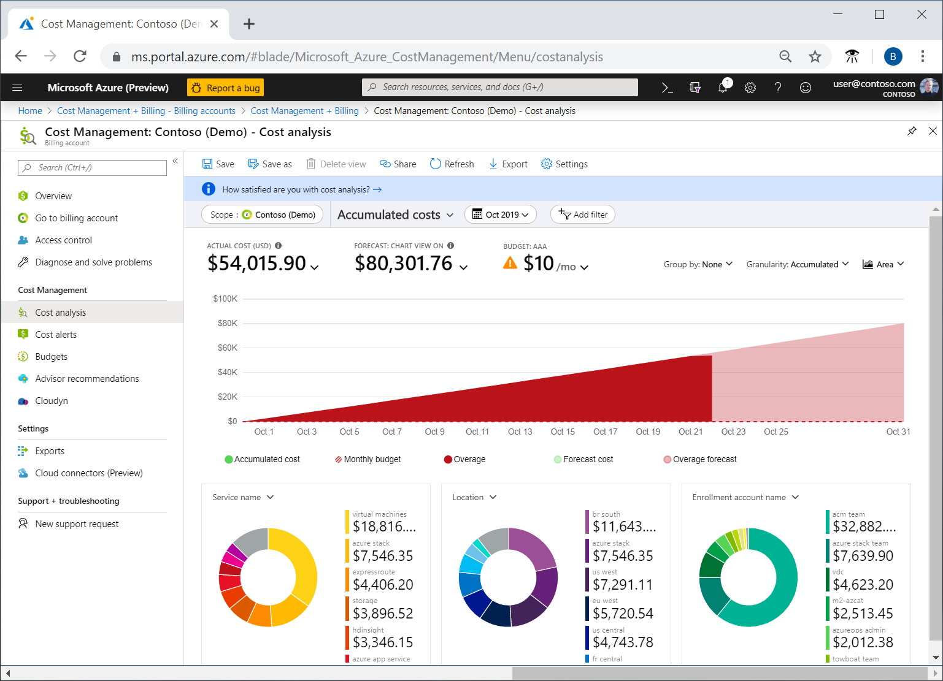

You use cost analysis to explore and analyze your organizational costs. You can view aggregated costs by organization to understand where costs are accrued and to identify spending trends. And you can see accumulated costs over time to estimate monthly, quarterly, or even yearly cost trends against a budget.

## Cost alerts

Cost alerts provide a single location to quickly check on all of the different alert types that may show up in the Cost Management service. The three types of alerts that may show up are:

* Budget alerts
* Credit alerts
* Department spending quota alerts.

### Budget alerts

Budget alerts notify you when spending, based on usage or cost, reaches or exceeds the amount defined in the alert condition of the budget. Cost Management budgets are created using the Azure portal or the Azure Consumption API.

In the Azure portal, budgets are defined by cost. Budgets are defined by cost or by consumption usage when using the Azure Consumption API. Budget alerts support both cost-based and usage-based budgets. Budget alerts are generated automatically whenever the budget alert conditions are met. You can view all cost alerts in the Azure portal. Whenever an alert is generated, it appears in cost alerts. An alert email is also sent to the people in the alert recipients list of the budget.

### Credit alerts

Credit alerts notify you when your Azure credit monetary commitments are consumed. Monetary commitments are for organizations with Enterprise Agreements (EAs). Credit alerts are generated automatically at 90% and at 100% of your Azure credit balance. Whenever an alert is generated, it's reflected in cost alerts, and in the email sent to the account owners.

### Department spending quota alerts

Department spending quota alerts notify you when department spending reaches a fixed threshold of the quota. Spending quotas are configured in the EA portal. Whenever a threshold is met, it generates an email to department owners, and appears in cost alerts. For example, 50 percent or 75 percent of the quota.

## Budgets

A budget is where you set a spending limit for Azure. You can set budgets based on a subscription, resource group, service type, or other criteria. When you set a budget, you will also set a budget alert. When the budget hits the budget alert level, it will trigger a budget alert that shows up in the cost alerts area. If configured, budget alerts will also send an email notification that a budget alert threshold has been triggered.

A more advanced use of budgets enables budget conditions to trigger automation that suspends or otherwise modifies resources once the trigger condition has occurred.

# Describe the purpose of tags

As your cloud usage grows, it's increasingly important to stay organized. A good organization strategy helps you understand your cloud usage and can help you manage costs.

One way to organize related resources is to place them in their own subscriptions. You can also use resource groups to manage related resources. Resource tags are another way to organize resources. Tags provide extra information, or metadata, about your resources. This metadata is useful for:

* **Resource management** Tags enable you to locate and act on resources that are associated with specific workloads, environments, business units, and owners.
* **Cost management and optimization** Tags enable you to group resources so that you can report on costs, allocate internal cost centers, track budgets, and forecast estimated cost.
* **Operations management** Tags enable you to group resources according to how critical their availability is to your business. This grouping helps you formulate service-level agreements (SLAs). An SLA is an uptime or performance guarantee between you and your users.
* **Security** Tags enable you to classify data by its security level, such as public or confidential.
* **Governance and regulatory compliance** Tags enable you to identify resources that align with governance or regulatory compliance requirements, such as ISO 27001. Tags can also be part of your standards enforcement efforts. For example, you might require that all resources be tagged with an owner or department name.
* **Workload optimization and automation** Tags can help you visualize all of the resources that participate in complex deployments. For example, you might tag a resource with its associated workload or application name and use software such as Azure DevOps to perform automated tasks on those resources.

## How do I manage resource tags?

You can add, modify, or delete resource tags through Windows PowerShell, the Azure CLI, Azure Resource Manager templates, the REST API, or the Azure portal.

You can use Azure Policy to enforce tagging rules and conventions. For example, you can require that certain tags be added to new resources as they're provisioned. You can also define rules that reapply tags that have been removed. Resources don't inherit tags from subscriptions and resource groups, meaning that you can apply tags at one level and not have those tags automatically show up at a different level, allowing you to create custom tagging schemas that change depending on the level (resource, resource group, subscription, and so on).

### An example tagging structure

A resource tag consists of a name and a value. You can assign one or more tags to each Azure resource.

Expand table

| **Name** | **Value** |
| --- | --- |
| AppName | The name of the application that the resource is part of. |
| CostCenter | The internal cost center code. |
| Owner | The name of the business owner who's responsible for the resource. |
| Environment | An environment name, such as "Prod," "Dev," or "Test." |
| Impact | How important the resource is to business operations, such as "Mission-critical," "High-impact," or "Low-impact." |

Keep in mind that you don't need to enforce that a specific tag is present on all of your resources. For example, you might decide that only mission-critical resources have the Impact tag. All non-tagged resources would then not be considered as mission-critical.

# Describe the purpose of Microsoft Purview

Microsoft Purview is a family of data governance, risk, and compliance solutions that helps you get a single, unified view into your data. Microsoft Purview brings insights about your on-premises, multicloud, and software-as-a-service data together.

With Microsoft Purview, you can stay up-to-date on your data landscape thanks to:

* Automated data discovery
* Sensitive data classification
* End-to-end data lineage

Two main solution areas comprise Microsoft Purview: **risk and compliance** and **unified data governance**.

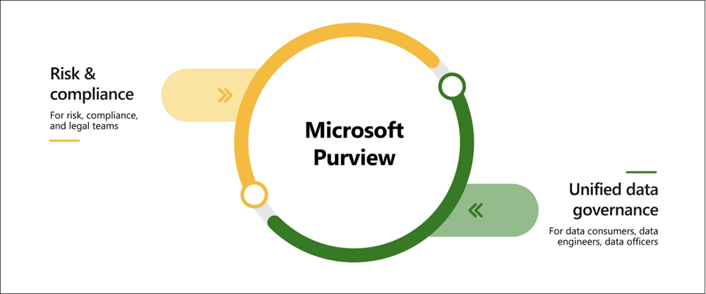

## Microsoft Purview risk and compliance solutions

Microsoft 365 features as a core component of the Microsoft Purview risk and compliance solutions. Microsoft Teams, OneDrive, and Exchange are just some of the Microsoft 365 services that Microsoft Purview uses to help manage and monitor your data. Microsoft Purview, by managing and monitoring your data, is able to help your organization:

* Protect sensitive data across clouds, apps, and devices.
* Identify data risks and manage regulatory compliance requirements.
* Get started with regulatory compliance.

## Unified data governance

Microsoft Purview has robust, unified data governance solutions that help manage your on-premises, multicloud, and software as a service data. Microsoft Purview’s robust data governance capabilities enable you to manage your data stored in Azure, SQL and Hive databases, locally, and even in other clouds like Amazon S3.

Microsoft Purview’s unified data governance helps your organization:

* Create an up-to-date map of your entire data estate that includes data classification and end-to-end lineage.
* Identify where sensitive data is stored in your estate.
* Create a secure environment for data consumers to find valuable data.
* Generate insights about how your data is stored and used.
* Manage access to the data in your estate securely and at scale.

# Describe the purpose of Azure Policy

How do you ensure that your resources stay compliant? Can you be alerted if a resource's configuration has changed?

Azure Policy is a service in Azure that enables you to create, assign, and manage policies that control or audit your resources. These policies enforce different rules across your resource configurations so that those configurations stay compliant with corporate standards.

## How does Azure Policy define policies?

Azure Policy enables you to define both individual policies and groups of related policies, known as initiatives. Azure Policy evaluates your resources and highlights resources that aren't compliant with the policies you've created. Azure Policy can also prevent noncompliant resources from being created.

Azure Policies can be set at each level, enabling you to set policies on a specific resource, resource group, subscription, and so on. Additionally, Azure Policies are inherited, so if you set a policy at a high level, it will automatically be applied to all of the groupings that fall within the parent. For example, if you set an Azure Policy on a resource group, all resources created within that resource group will automatically receive the same policy.

Azure Policy comes with built-in policy and initiative definitions for Storage, Networking, Compute, Security Center, and Monitoring. For example, if you define a policy that allows only a certain size for the virtual machines (VMs) to be used in your environment, that policy is invoked when you create a new VM and whenever you resize existing VMs. Azure Policy also evaluates and monitors all current VMs in your environment, including VMs that were created before the policy was created.

In some cases, Azure Policy can automatically remediate noncompliant resources and configurations to ensure the integrity of the state of the resources. For example, if all resources in a certain resource group should be tagged with AppName tag and a value of "SpecialOrders," Azure Policy will automatically apply that tag if it is missing. However, you still retain full control of your environment. If you have a specific resource that you don’t want Azure Policy to automatically fix, you can flag that resource as an exception – and the policy won’t automatically fix that resource.

Azure Policy also integrates with Azure DevOps by applying any continuous integration and delivery pipeline policies that pertain to the pre-deployment and post-deployment phases of your applications.

## What are Azure Policy initiatives?

An Azure Policy initiative is a way of grouping related policies together. The initiative definition contains all of the policy definitions to help track your compliance state for a larger goal.

For example, Azure Policy includes an initiative named Enable Monitoring in Azure Security Center. Its goal is to monitor all available security recommendations for all Azure resource types in Azure Security Center.

Under this initiative, the following policy definitions are included:

* **Monitor unencrypted SQL Database in Security Center** This policy monitors for unencrypted SQL databases and servers.
* **Monitor OS vulnerabilities in Security Center** This policy monitors servers that don't satisfy the configured OS vulnerability baseline.
* **Monitor missing Endpoint Protection in Security Center** This policy monitors for servers that don't have an installed endpoint protection agent.

In fact, the Enable Monitoring in Azure Security Center initiative contains over 100 separate policy definitions.

# Describe the purpose of resource locks

A resource lock prevents resources from being accidentally deleted or changed.

Even with Azure role-based access control (Azure RBAC) policies in place, there's still a risk that people with the right level of access could delete critical cloud resources. Resource locks prevent resources from being deleted or updated, depending on the type of lock. Resource locks can be applied to individual resources, resource groups, or even an entire subscription. Resource locks are inherited, meaning that if you place a resource lock on a resource group, all of the resources within the resource group will also have the resource lock applied.

## Types of Resource Locks

There are two types of resource locks, one that prevents users from deleting and one that prevents users from changing or deleting a resource.

* Delete means authorized users can still read and modify a resource, but they can't delete the resource.
* ReadOnly means authorized users can read a resource, but they can't delete or update the resource. Applying this lock is similar to restricting all authorized users to the permissions granted by the Reader role.

## How do I manage resource locks?

You can manage resource locks from the Azure portal, PowerShell, the Azure CLI, or from an Azure Resource Manager template.

To view, add, or delete locks in the Azure portal, go to the Settings section of any resource's Settings pane in the Azure portal.

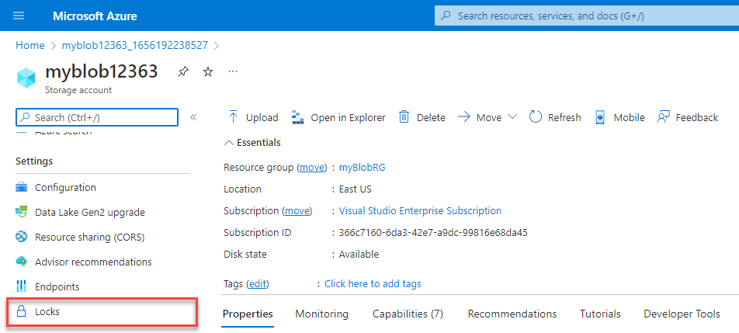

## How do I delete or change a locked resource?

Although locking helps prevent accidental changes, you can still make changes by following a two-step process.

To modify a locked resource, you must first remove the lock. After you remove the lock, you can apply any action you have permissions to perform. Resource locks apply regardless of RBAC permissions. Even if you're an owner of the resource, you must still remove the lock before you can perform the blocked activity.

# Describe the purpose of the Service Trust portal

The Microsoft Service Trust Portal is a portal that provides access to various content, tools, and other resources about Microsoft security, privacy, and compliance practices.

The Service Trust Portal contains details about Microsoft's implementation of controls and processes that protect our cloud services and the customer data therein. To access some of the resources on the Service Trust Portal, you must sign in as an authenticated user with your Microsoft cloud services account (Microsoft Entra organization account). You'll need to review and accept the Microsoft non-disclosure agreement for compliance materials.

## Accessing the Service Trust Portal

You can access the Service Trust Portal at <https://servicetrust.microsoft.com/>.

# Describe tools for interacting with Azure

To get the most out of Azure, you need a way to interact with the Azure environment, the management groups, subscriptions, resource groups, resources, and so on. Azure provides multiple tools for managing your environment, including the:

* Azure portal
* Azure PowerShell
* Azure Command Line Interface (CLI)

## What is the Azure portal?

The Azure portal is a web-based, unified console that provides an alternative to command-line tools. With the Azure portal, you can manage your Azure subscription by using a graphical user interface. You can:

* Build, manage, and monitor everything from simple web apps to complex cloud deployments
* Create custom dashboards for an organized view of resources
* Configure accessibility options for an optimal experience

The following video introduces you to the Azure portal:

The Azure portal is designed for resiliency and continuous availability. It maintains a presence in every Azure datacenter. This configuration makes the Azure portal resilient to individual datacenter failures and avoids network slowdowns by being close to users. The Azure portal updates continuously and requires no downtime for maintenance activities.

### Azure Cloud Shell

Azure Cloud Shell is a browser-based shell tool that allows you to create, configure, and manage Azure resources using a shell. Azure Cloud Shell support both Azure PowerShell and the Azure Command Line Interface (CLI), which is a Bash shell.

You can access Azure Cloud Shell via the Azure portal by selecting the Cloud Shell icon:

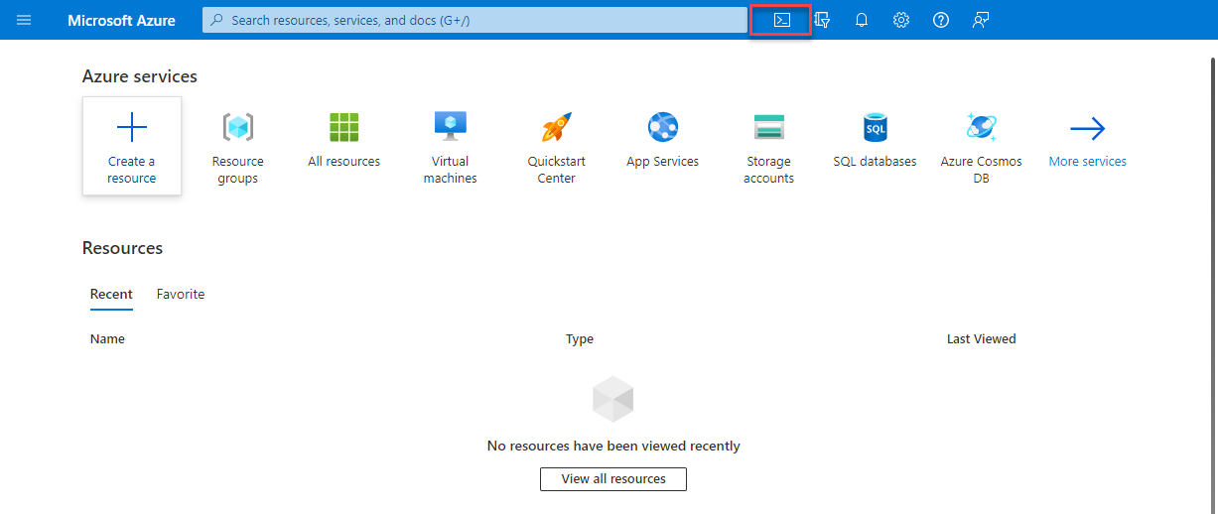

Azure Cloud Shell has several features that make it a unique offering to support you in managing Azure. Some of those features are:

* It is a browser-based shell experience, with no local installation or configuration required.
* It is authenticated to your Azure credentials, so when you log in it inherently knows who you are and what permissions you have.
* You choose the shell you’re most familiar with; Azure Cloud Shell supports both Azure PowerShell and the Azure CLI (which uses Bash).

## What is Azure PowerShell?

Azure PowerShell is a shell with which developers, DevOps, and IT professionals can run commands called command-lets (cmdlets). These commands call the Azure REST API to perform management tasks in Azure. Cmdlets can be run independently to handle one-off changes, or they may be combined to help orchestrate complex actions such as:

* The routine setup, teardown, and maintenance of a single resource or multiple connected resources.
* The deployment of an entire infrastructure, which might contain dozens or hundreds of resources, from imperative code.

Capturing the commands in a script makes the process repeatable and automatable.

In addition to be available via Azure Cloud Shell, you can install and configure Azure PowerShell on Windows, Linux, and Mac platforms.

## What is the Azure CLI?

The Azure CLI is functionally equivalent to Azure PowerShell, with the primary difference being the syntax of commands. While Azure PowerShell uses PowerShell commands, the Azure CLI uses Bash commands.

The Azure CLI provides the same benefits of handling discrete tasks or orchestrating complex operations through code. It’s also installable on Windows, Linux, and Mac platforms, as well as through Azure Cloud Shell.

Due to the similarities in capabilities and access between Azure PowerShell and the Bash based Azure CLI, it mainly comes down to which language you’re most familiar with.

# Describe the purpose of Azure Arc

Managing hybrid and multi-cloud environments can rapidly get complicated. Azure provides a host of tools to provision, configure, and monitor Azure resources. What about the on-premises resources in a hybrid configuration or the cloud resources in a multi-cloud configuration?

In utilizing Azure Resource Manager (ARM), Arc lets you extend your Azure compliance and monitoring to your hybrid and multi-cloud configurations. Azure Arc simplifies governance and management by delivering a consistent multi-cloud and on-premises management platform.

Azure Arc provides a centralized, unified way to:

* Manage your entire environment together by projecting your existing non-Azure resources into ARM.
* Manage multi-cloud and hybrid virtual machines, Kubernetes clusters, and databases as if they are running in Azure.
* Use familiar Azure services and management capabilities, regardless of where they live.
* Continue using traditional ITOps while introducing DevOps practices to support new cloud and native patterns in your environment.
* Configure custom locations as an abstraction layer on top of Azure Arc-enabled Kubernetes clusters and cluster extensions.

## What can Azure Arc do outside of Azure?

Currently, Azure Arc allows you to manage the following resource types hosted outside of Azure:

* Servers
* Kubernetes clusters
* Azure data services
* SQL Server
* Virtual machines (preview)

# Describe Azure Resource Manager and Azure ARM templates

Azure Resource Manager (ARM) is the deployment and management service for Azure. It provides a management layer that enables you to create, update, and delete resources in your Azure account. Anytime you do anything with your Azure resources, ARM is involved.

When a user sends a request from any of the Azure tools, APIs, or SDKs, ARM receives the request. ARM authenticates and authorizes the request. Then, ARM sends the request to the Azure service, which takes the requested action. You see consistent results and capabilities in all the different tools because all requests are handled through the same API.

## Azure Resource Manager benefits

With Azure Resource Manager, you can:

* Manage your infrastructure through declarative templates rather than scripts. A Resource Manager template is a JSON file that defines what you want to deploy to Azure.
* Deploy, manage, and monitor all the resources for your solution as a group, rather than handling these resources individually.
* Re-deploy your solution throughout the development life-cycle and have confidence your resources are deployed in a consistent state.
* Define the dependencies between resources, so they're deployed in the correct order.
* Apply access control to all services because RBAC is natively integrated into the management platform.
* Apply tags to resources to logically organize all the resources in your subscription.
* Clarify your organization's billing by viewing costs for a group of resources that share the same tag.

The following video provides an overview of Azure Resource Manager.

## Infrastructure as code

Infrastructure as code is a concept where you manage your infrastructure as lines of code. At an introductory level, it's things like using Azure Cloud Shell, Azure PowerShell, or the Azure CLI to manage and configure your resources. As you get more comfortable in the cloud, you can use the infrastructure as code concept to manage entire deployments using repeatable templates and configurations. ARM templates and Bicep are two examples of using infrastructure as code with the Azure Resource Manager to maintain your environment.

### ARM templates

By using ARM templates, you can describe the resources you want to use in a declarative JSON format. With an ARM template, the deployment code is verified before any code is run. This ensures that the resources will be created and connected correctly. The template then orchestrates the creation of those resources in parallel. That is, if you need 50 instances of the same resource, all 50 instances are created at the same time.

Ultimately, the developer, DevOps professional, or IT professional needs only to define the desired state and configuration of each resource in the ARM template, and the template does the rest. Templates can even execute PowerShell and Bash scripts before or after the resource has been set up.

### Benefits of using ARM templates

ARM templates provide many benefits when planning for deploying Azure resources. Some of those benefits include:

* **Declarative syntax**: ARM templates allow you to create and deploy an entire Azure infrastructure declaratively. Declarative syntax means you declare what you want to deploy but don’t need to write the actual programming commands and sequence to deploy the resources.
* **Repeatable results**: Repeatedly deploy your infrastructure throughout the development lifecycle and have confidence your resources are deployed in a consistent manner. You can use the same ARM template to deploy multiple dev/test environments, knowing that all the environments are the same.
* **Orchestration**: You don't have to worry about the complexities of ordering operations. Azure Resource Manager orchestrates the deployment of interdependent resources, so they're created in the correct order. When possible, Azure Resource Manager deploys resources in parallel, so your deployments finish faster than serial deployments. You deploy the template through one command, rather than through multiple imperative commands.
* **Modular files**: You can break your templates into smaller, reusable components and link them together at deployment time. You can also nest one template inside another template. For example, you could create a template for a VM stack, and then nest that template inside of templates that deploy entire environments, and that VM stack will consistently be deployed in each of the environment templates.
* **Extensibility**: With deployment scripts, you can add PowerShell or Bash scripts to your templates. The deployment scripts extend your ability to set up resources during deployment. A script can be included in the template or stored in an external source and referenced in the template. Deployment scripts give you the ability to complete your end-to-end environment setup in a single ARM template.

### Bicep

Bicep is a language that uses declarative syntax to deploy Azure resources. A Bicep file defines the infrastructure and configuration. Then, ARM deploys that environment based on your Bicep file. While similar to an ARM template, which is written in JSON, Bicep files tend to use a simpler, more concise style.

Some benefits of Bicep are:

* **Support for all resource types and API versions**: Bicep immediately supports all preview and GA versions for Azure services. As soon as a resource provider introduces new resource types and API versions, you can use them in your Bicep file. You don't have to wait for tools to be updated before using the new services.
* **Simple syntax**: When compared to the equivalent JSON template, Bicep files are more concise and easier to read. Bicep requires no previous knowledge of programming languages. Bicep syntax is declarative and specifies which resources and resource properties you want to deploy.
* **Repeatable results**: Repeatedly deploy your infrastructure throughout the development lifecycle and have confidence your resources are deployed in a consistent manner. Bicep files are idempotent, which means you can deploy the same file many times and get the same resource types in the same state. You can develop one file that represents the desired state, rather than developing lots of separate files to represent updates.
* **Orchestration**: You don't have to worry about the complexities of ordering operations. Resource Manager orchestrates the deployment of interdependent resources so they're created in the correct order. When possible, Resource Manager deploys resources in parallel so your deployments finish faster than serial deployments. You deploy the file through one command, rather than through multiple imperative commands.
* **Modularity**: You can break your Bicep code into manageable parts by using modules. The module deploys a set of related resources. Modules enable you to reuse code and simplify development. Add the module to a Bicep file anytime you need to deploy those resources.

# Describe the purpose of Azure Advisor

Azure Advisor evaluates your Azure resources and makes recommendations to help improve reliability, security, and performance, achieve operational excellence, and reduce costs. Azure Advisor is designed to help you save time on cloud optimization. The recommendation service includes suggested actions you can take right away, postpone, or dismiss.

The recommendations are available via the Azure portal and the API, and you can set up notifications to alert you to new recommendations.

When you're in the Azure portal, the Advisor dashboard displays personalized recommendations for all your subscriptions. You can use filters to select recommendations for specific subscriptions, resource groups, or services. The recommendations are divided into five categories:

* **Reliability** is used to ensure and improve the continuity of your business-critical applications.
* **Security** is used to detect threats and vulnerabilities that might lead to security breaches.
* **Performance** is used to improve the speed of your applications.
* **Operational Excellence** is used to help you achieve process and workflow efficiency, resource manageability, and deployment best practices.
* **Cost** is used to optimize and reduce your overall Azure spending.

The following image shows the Azure Advisor dashboard.

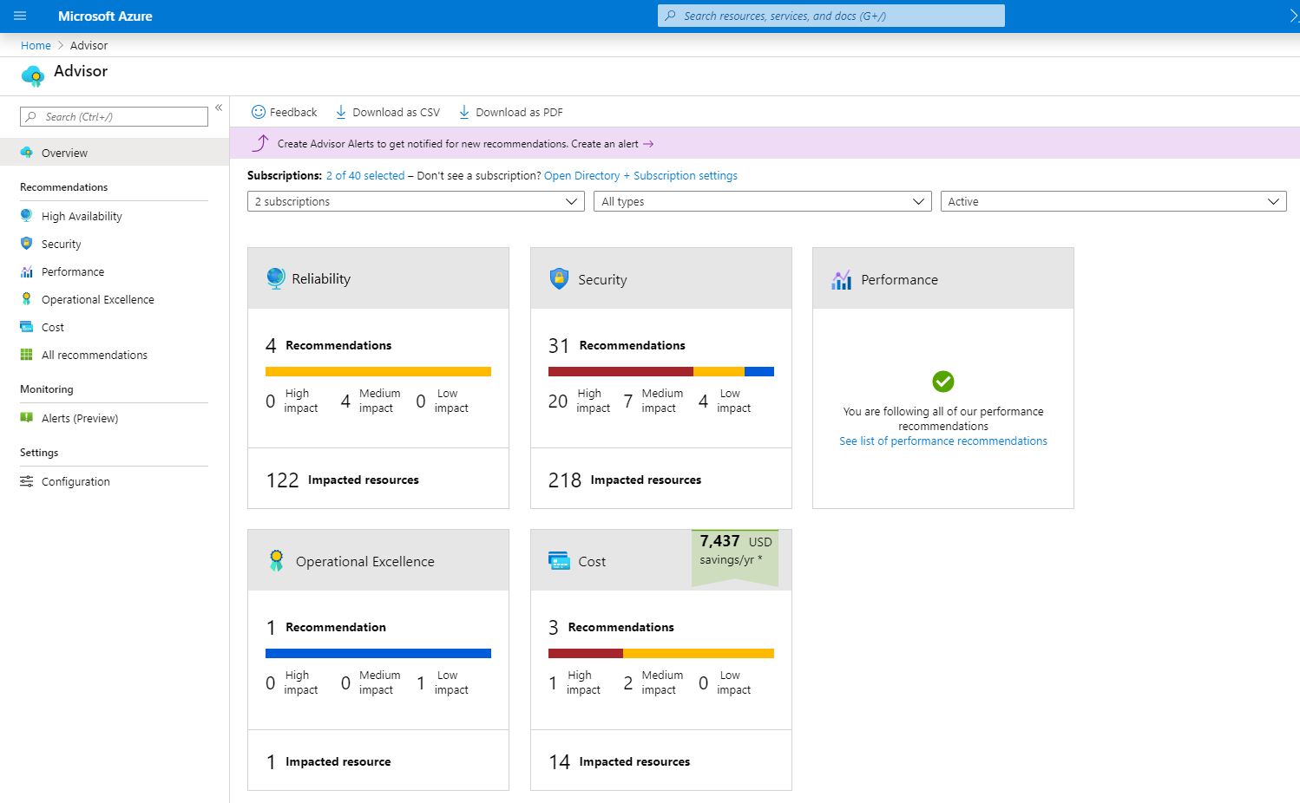

# Describe Azure Service Health

Microsoft Azure provides a global cloud solution to help you manage your infrastructure needs, reach your customers, innovate, and adapt rapidly. Knowing the status of the global Azure infrastructure and your individual resources may seem like a daunting task. Azure Service Health helps you keep track of Azure resource, both your specifically deployed resources and the overall status of Azure. Azure service health does this by combining three different Azure services:

* **Azure Status** is a broad picture of the status of Azure globally. Azure status informs you of service outages in Azure on the Azure Status page. The page is a global view of the health of all Azure services across all Azure regions. It’s a good reference for incidents with widespread impact.
* **Service Health** provides a narrower view of Azure services and regions. It focuses on the Azure services and regions you're using. This is the best place to look for service impacting communications about outages, planned maintenance activities, and other health advisories because the authenticated Service Health experience knows which services and resources you currently use. You can even set up Service Health alerts to notify you when service issues, planned maintenance, or other changes may affect the Azure services and regions you use.
* **Resource Health** is a tailored view of your actual Azure resources. It provides information about the health of your individual cloud resources, such as a specific virtual machine instance. Using Azure Monitor, you can also configure alerts to notify you of availability changes to your cloud resources.

By using Azure status, Service health, and Resource Health, Azure Service Health gives you a complete view of your Azure environment-all the way from the global status of Azure services and regions down to specific resources. Additionally, historical alerts are stored and accessible for later review. Something you initially thought was a simple anomaly that turned into a trend, can readily be reviewed and investigated thanks to the historical alerts.

Finally, in the event that a workload you’re running is impacted by an event, Azure Service Health provides links to support.

# Describe Azure Monitor

Azure Monitor is a platform for collecting data on your resources, analyzing that data, visualizing the information, and even acting on the results. Azure Monitor can monitor Azure resources, your on-premises resources, and even multi-cloud resources like virtual machines hosted with a different cloud provider.

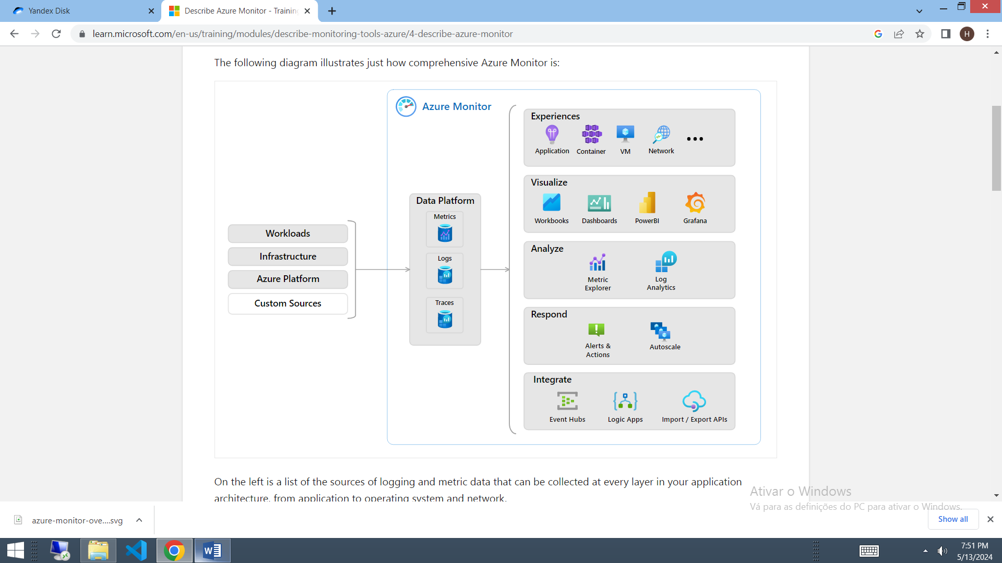

On the left is a list of the sources of logging and metric data that can be collected at every layer in your application architecture, from application to operating system and network.

In the center, the logging and metric data are stored in central repositories.

On the right, the data is used in several ways. You can view real-time and historical performance across each layer of your architecture or aggregated and detailed information. The data is displayed at different levels for different audiences. You can view high-level reports on the Azure Monitor Dashboard or create custom views by using Power BI and Kusto queries.

Additionally, you can use the data to help you react to critical events in real time, through alerts delivered to teams via SMS, email, and so on. Or you can use thresholds to trigger autoscaling functionality to scale to meet the demand.

## Azure Log Analytics

Azure Log Analytics is the tool in the Azure portal where you’ll write and run log queries on the data gathered by Azure Monitor. Log Analytics is a robust tool that supports both simple, complex queries, and data analysis. You can write a simple query that returns a set of records and then use features of Log Analytics to sort, filter, and analyze the records. You can write an advanced query to perform statistical analysis and visualize the results in a chart to identify a particular trend. Whether you work with the results of your queries interactively or use them with other Azure Monitor features such as log query alerts or workbooks, Log Analytics is the tool that you're going to use to write and test those queries.

## Azure Monitor Alerts

Azure Monitor Alerts are an automated way to stay informed when Azure Monitor detects a threshold being crossed. You set the alert conditions, the notification actions, and then Azure Monitor Alerts notifies when an alert is triggered. Depending on your configuration, Azure Monitor Alerts can also attempt corrective action.

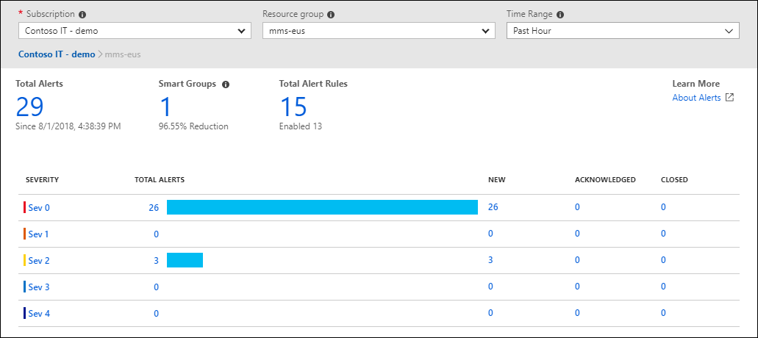

Alerts can be set up to monitor the logs and trigger on certain log events, or they can be set to monitor metrics and trigger when certain metrics are crossed. For example, you could set a metric-based alert up to notify you when the CPU usage on a virtual machine exceeded 80%. Alert rules based on metrics provide near real time alerts based on numeric values. Rules based on logs allow for complex logic across data from multiple sources.

Azure Monitor Alerts use action groups to configure who to notify and what action to take. An action group is simply a collection of notification and action preferences that you associate with one or multiple alerts. Azure Monitor, Service Health, and Azure Advisor all use actions groups to notify you when an alert has been triggered.

## Application Insights

Application Insights, an Azure Monitor feature, monitors your web applications. Application Insights is capable of monitoring applications that are running in Azure, on-premises, or in a different cloud environment.

There are two ways to configure Application Insights to help monitor your application. You can either install an SDK in your application, or you can use the Application Insights agent. The Application Insights agent is supported in C#.NET, VB.NET, Java, JavaScript, Node.js, and Python.

Once Application Insights is up and running, you can use it to monitor a broad array of information, such as:

* Request rates, response times, and failure rates
* Dependency rates, response times, and failure rates, to show whether external services are slowing down performance
* Page views and load performance reported by users' browsers
* AJAX calls from web pages, including rates, response times, and failure rates
* User and session counts
* Performance counters from Windows or Linux server machines, such as CPU, memory, and network usage

Not only does Application Insights help you monitor the performance of your application, but you can also configure it to periodically send synthetic requests to your application, allowing you to check the status and monitor your application even during periods of low activity.

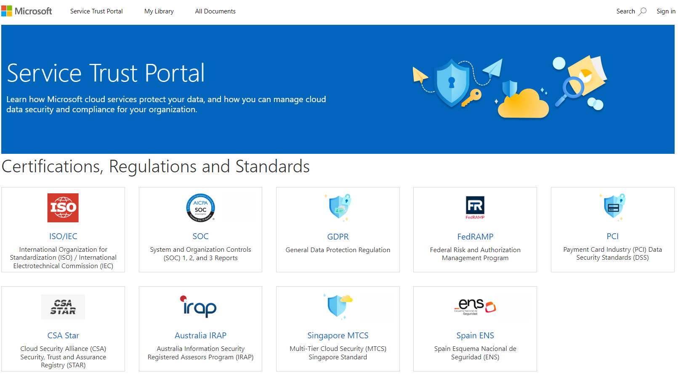

The Service Trust Portal features and content are accessible from the main menu. The categories on the main menu are:

* **Service Trust Portal** provides a quick access hyperlink to return to the Service Trust Portal home page.
* **My Library** lets you save (or pin) documents to quickly access them on your My Library page. You can also set up to receive notifications when documents in your My Library are updated.
* **All Documents** is a single landing place for documents on the service trust portal. From **All Documents**, you can pin documents to have them show up in your **My Library**.

**Note**

Service Trust Portal reports and documents are available to download for at least 12 months after publishing or until a new version of document becomes available.